

**Engineering Library**

**Reservation Application**

**Developed by**

Krist Pornpairin 6031301721

Kantorn Chitchuen 6030038521

This project is under subject 2110215 Programming Methodology (2018/1)

Computer Engineering, Faculty of Engineering, Chulalongkorn University

**Engineering Library**

Library is an important part of university. Not only being a place for student to learn and studies but also for sharing time with friend. But, in reality, most of the time this popular library is not enough for everyone. Many time, people come back with disappoint when they cannot find any seat for them self. Because of that, our team try to create the system for helping you reserving seat and checking seat status without actually come to the place.

Engineering Library are implemented is based on reality and friendly. How easy, even sign up is not necessary because the authenticate system is depend on Chulalongkorn University. Friendly design never come without pain, we have tried so hard to improve our user interface and friendly layout design because our design objective is “work like a pro without know any manual”. Crossing platform, that sound easy to us because all of the action can be done with only one stroke, integrate with touch screen is our near future plan.

Before the last. We like to thank you for your supporting and make this project finish. Hope this will be apply in real life.

Our team.

1. Overview of Application

The Engineering Library Reservation Application is a GUI application that can view available seats and take reservation on every seats in the library.

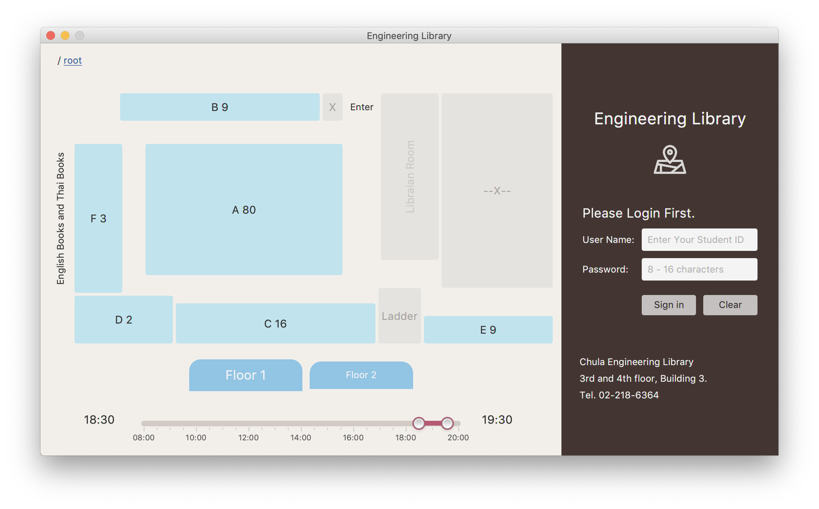

Fig 1: Start screen of the application

Start screen of the application has divided into 2 main parts. The left part shows a floor map of the library, user can click on a button “Floor 1” or “Floor 2” to switch the floor map between floor 1 and floor 2.

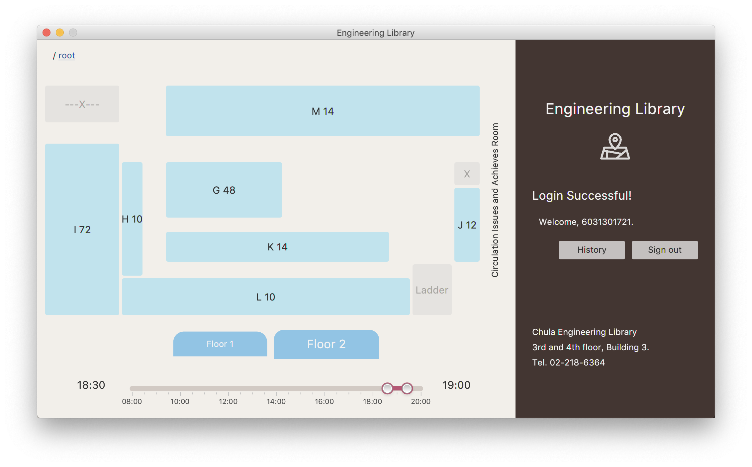

Fig 2: when user click on a “Floor 2” button and login.

When user want to take reservation on which seat, user have to login on the right pane, using student ID and password on the CUNET system. Then, user have to select start and end time user want to use, using slider bar at bottom of screen, the application will show available seat in zone as number after name of the zone. After that, user have to select a floor, a zone, and a seat which user desired. The application will take the user to appropriate screen.

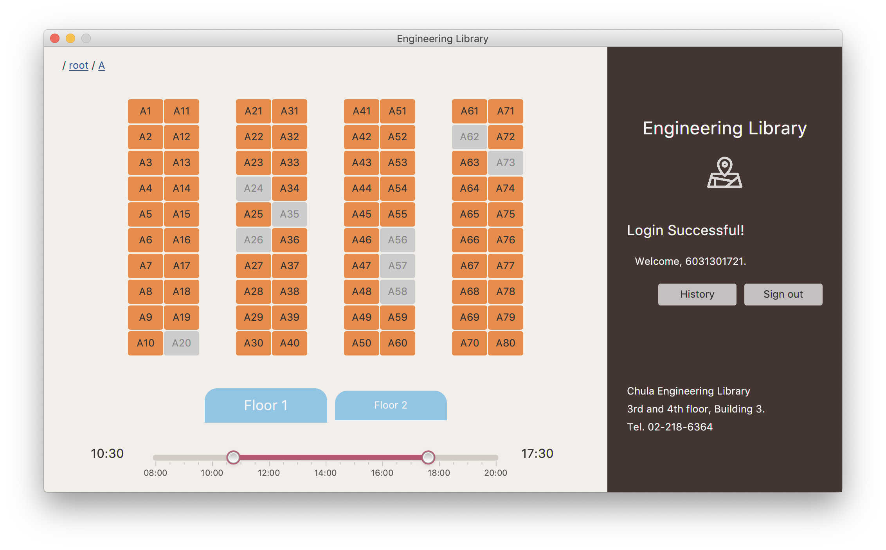

Fig 3: Selecting seat in zone A screen

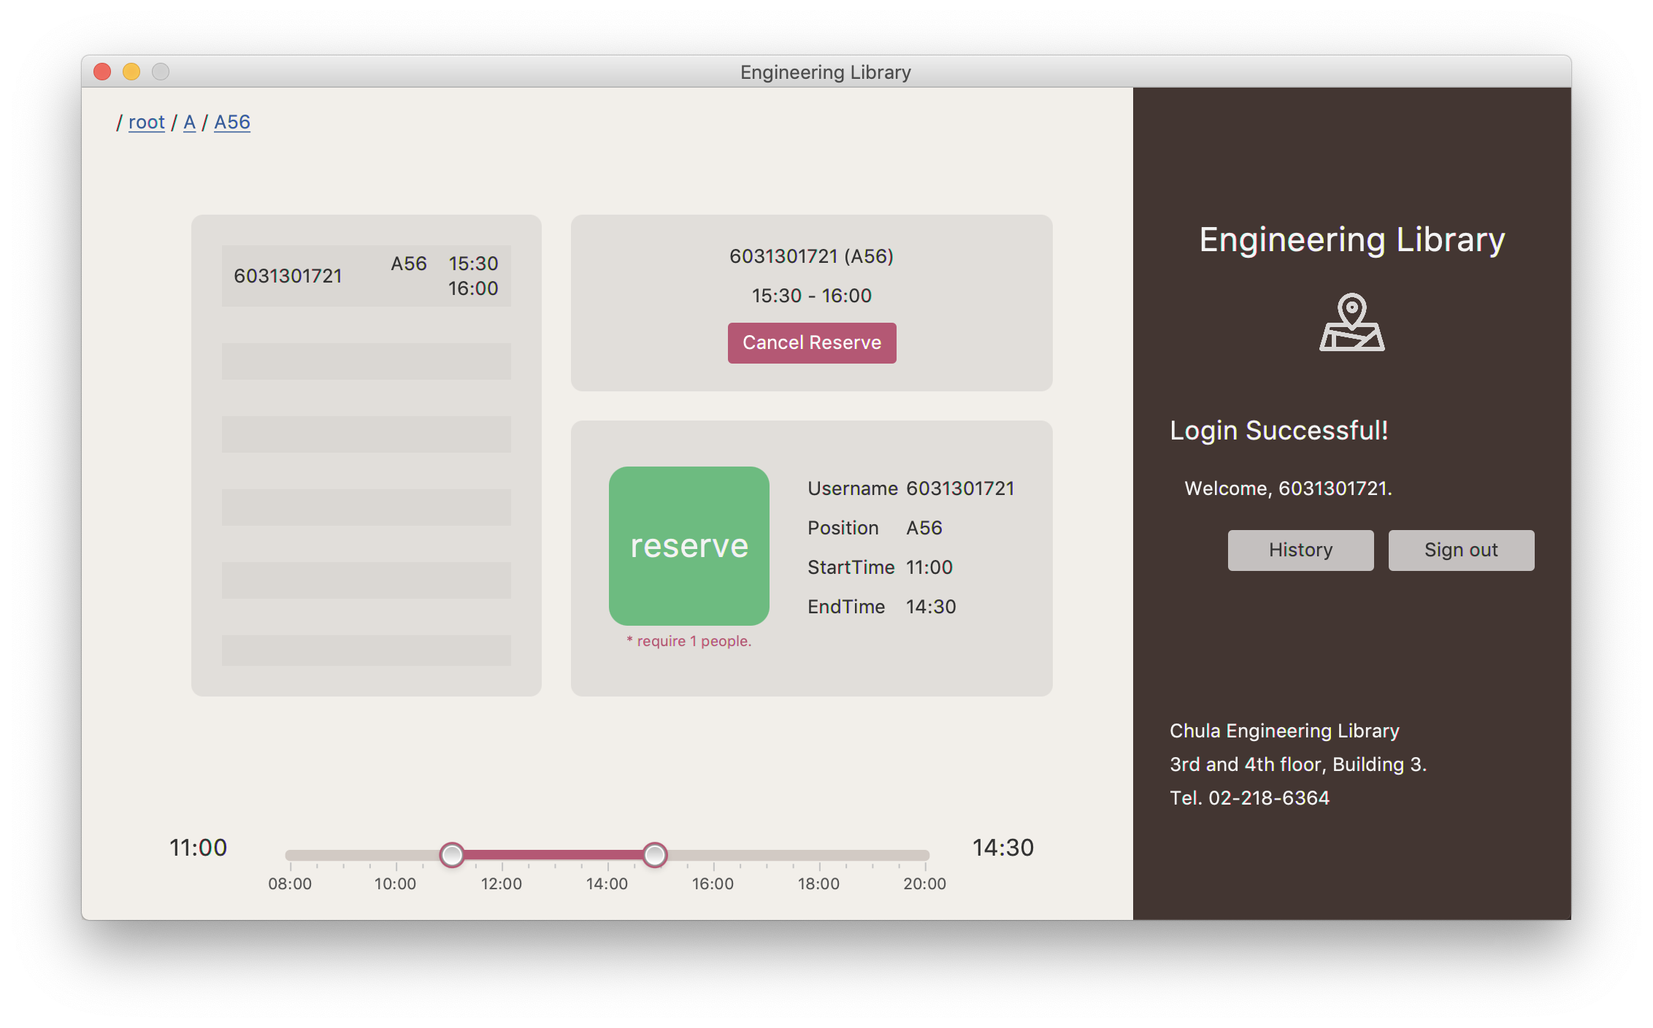

Fig 4: Reserving screen after user selected seat A56

When user have selected required data, because some zone has a table with more than one seat, user have to input ID (or IDs) of who user want to reserve with before take reservation.

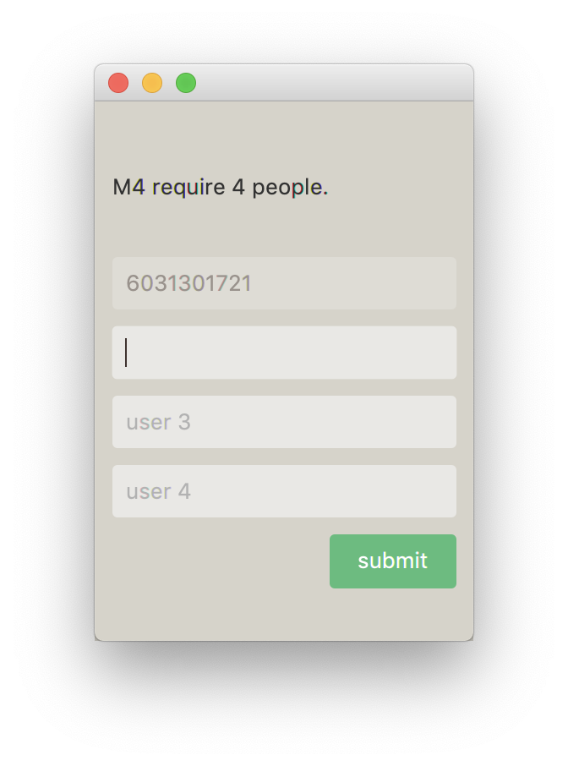

Fig 5: Screen when click on “reserve” button after selected required data.

When user login, user can check history of what user reserve, and logout when finish their work. However, user can check history of each seat and view overview map of library.

The details in each pane will show later.

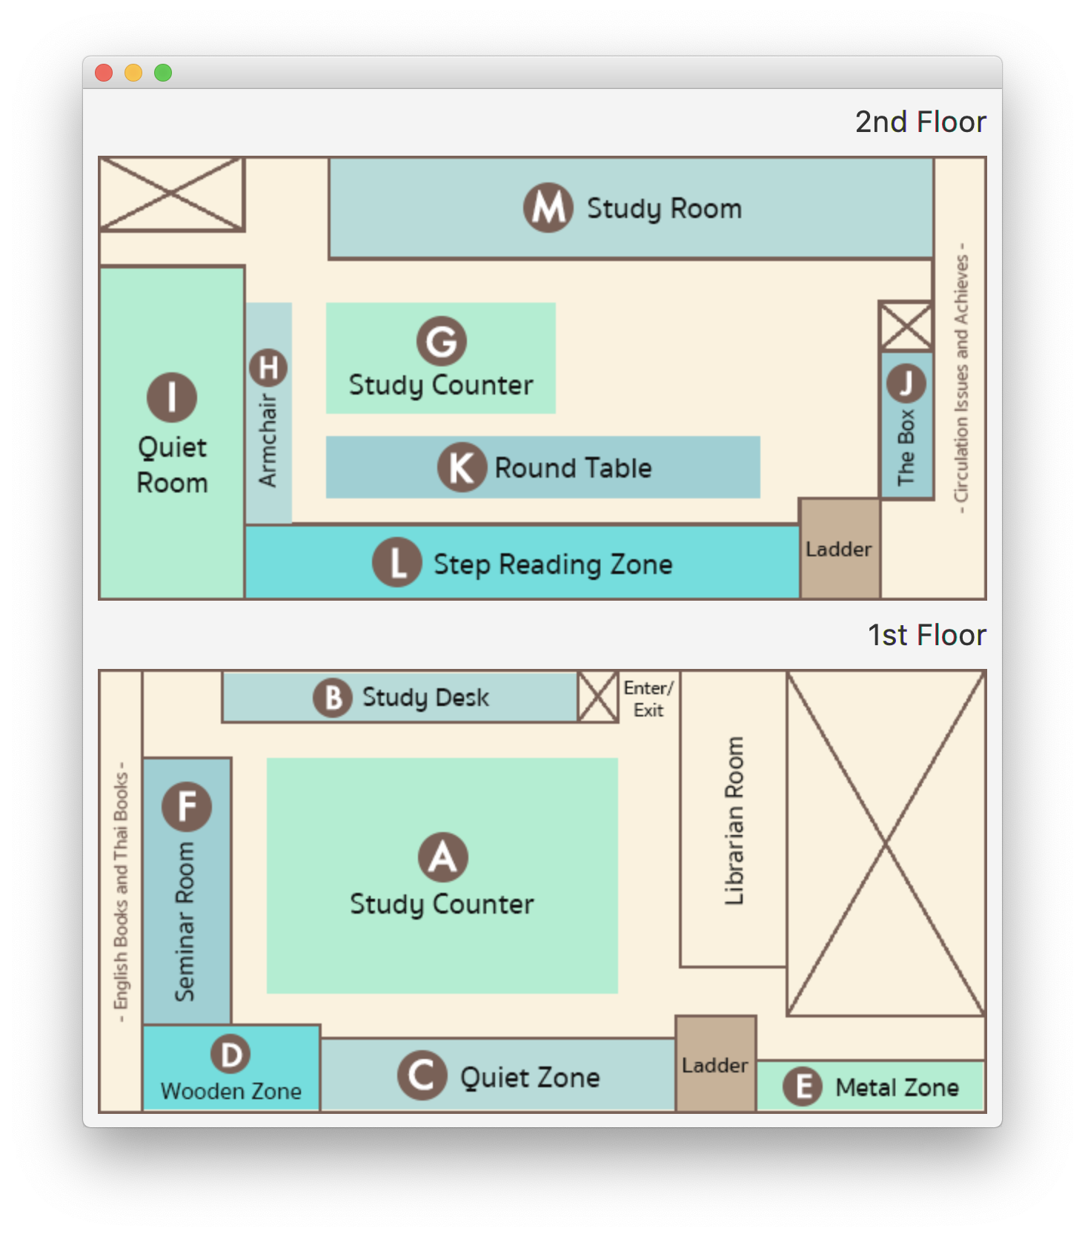

Fig 6: Overview map of library

2. Implementation Details

The diagram of the program is illustrated in figures below.

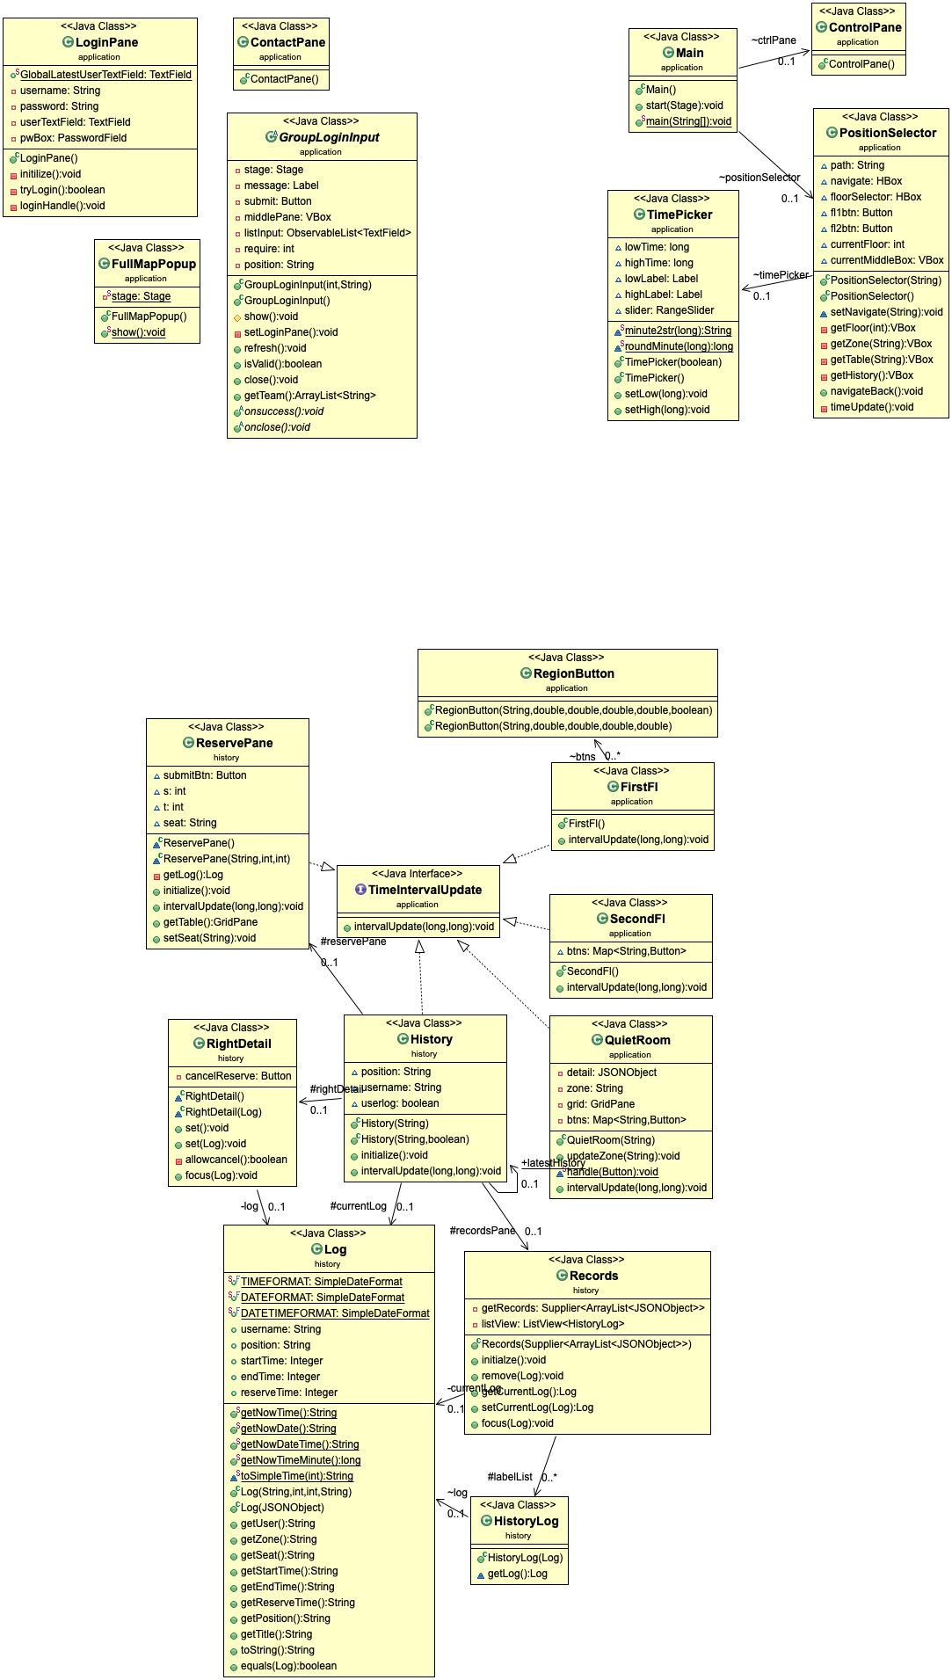

(a)



(b)



(c)

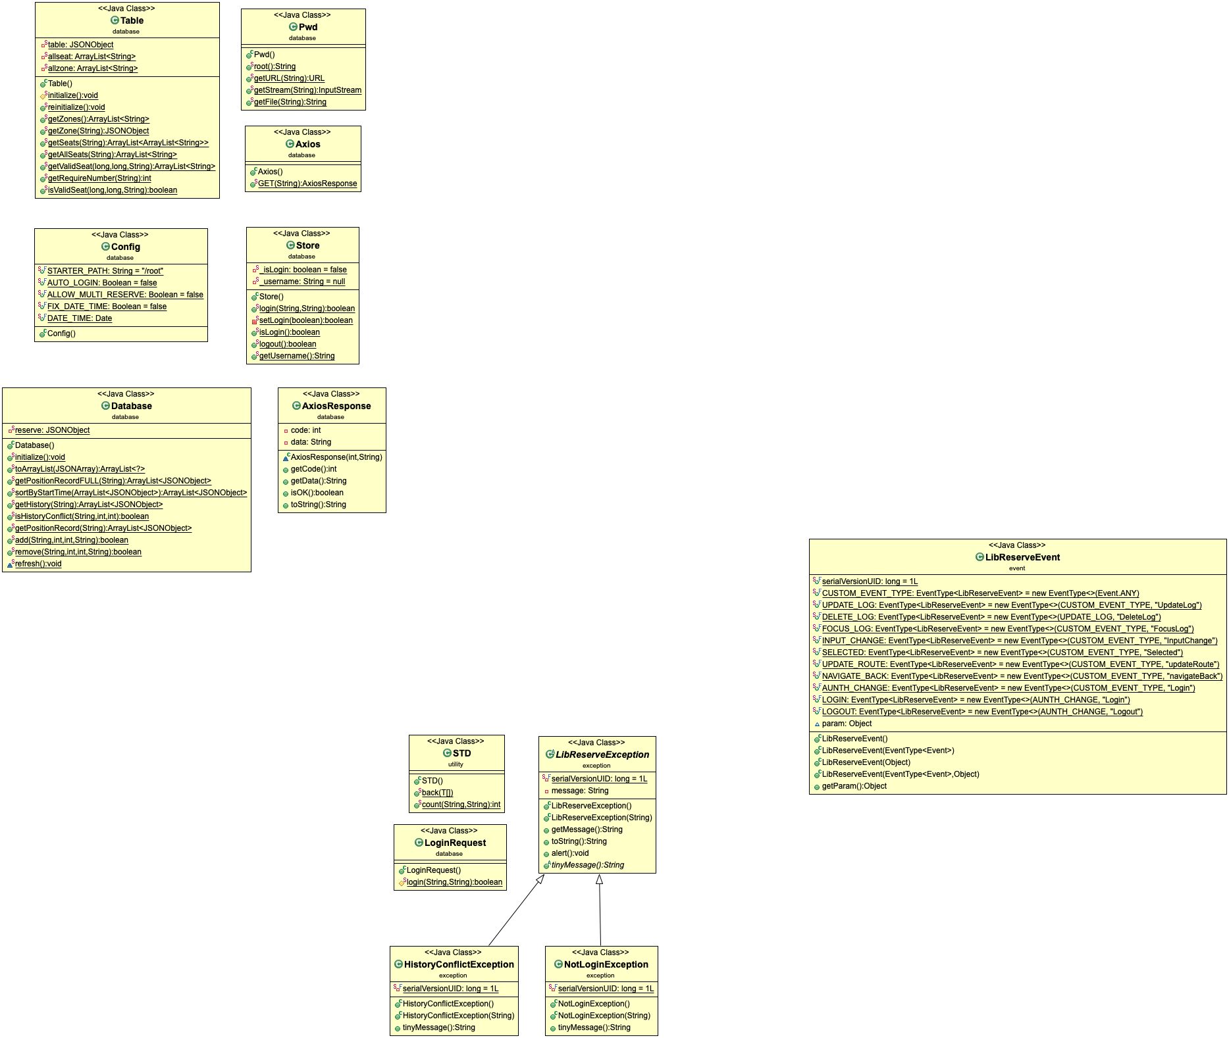

(d)



(e)



(f)

Fig : The UML diagram of the program

The structure of the GUI can be broken down as in figures below.

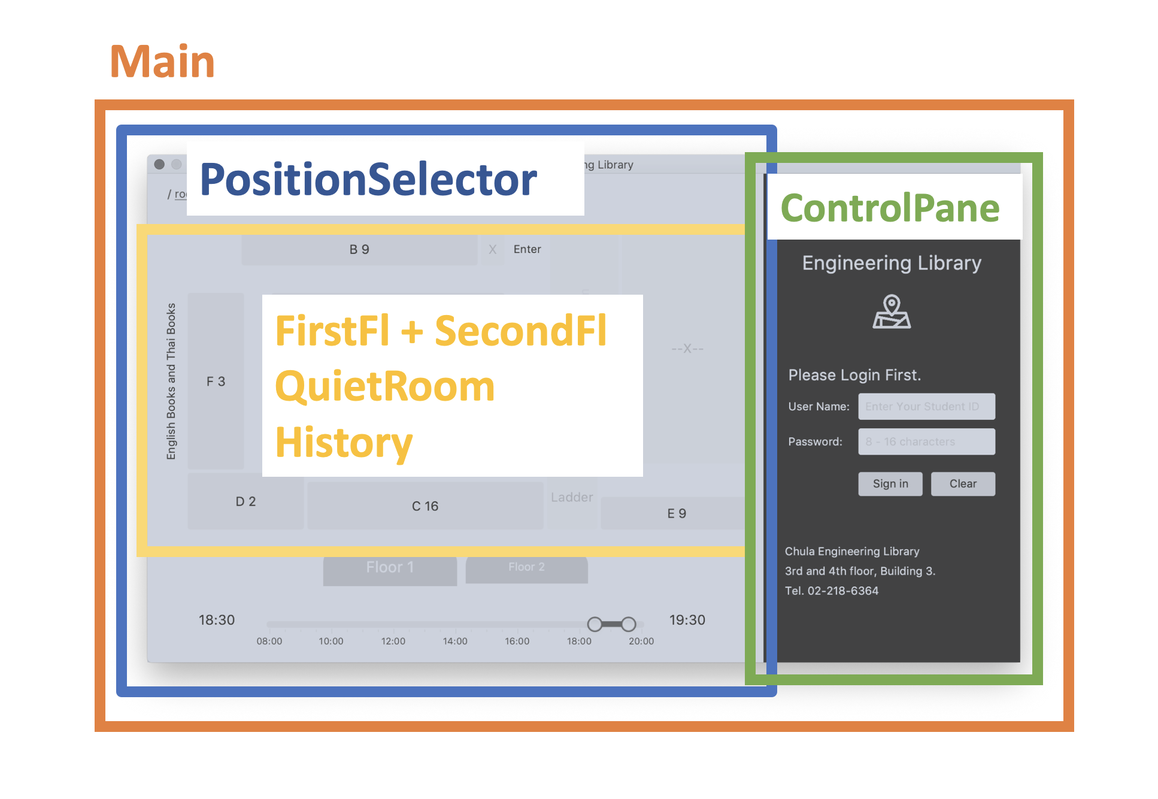

Fig 8: The outline showing the core structure of the program

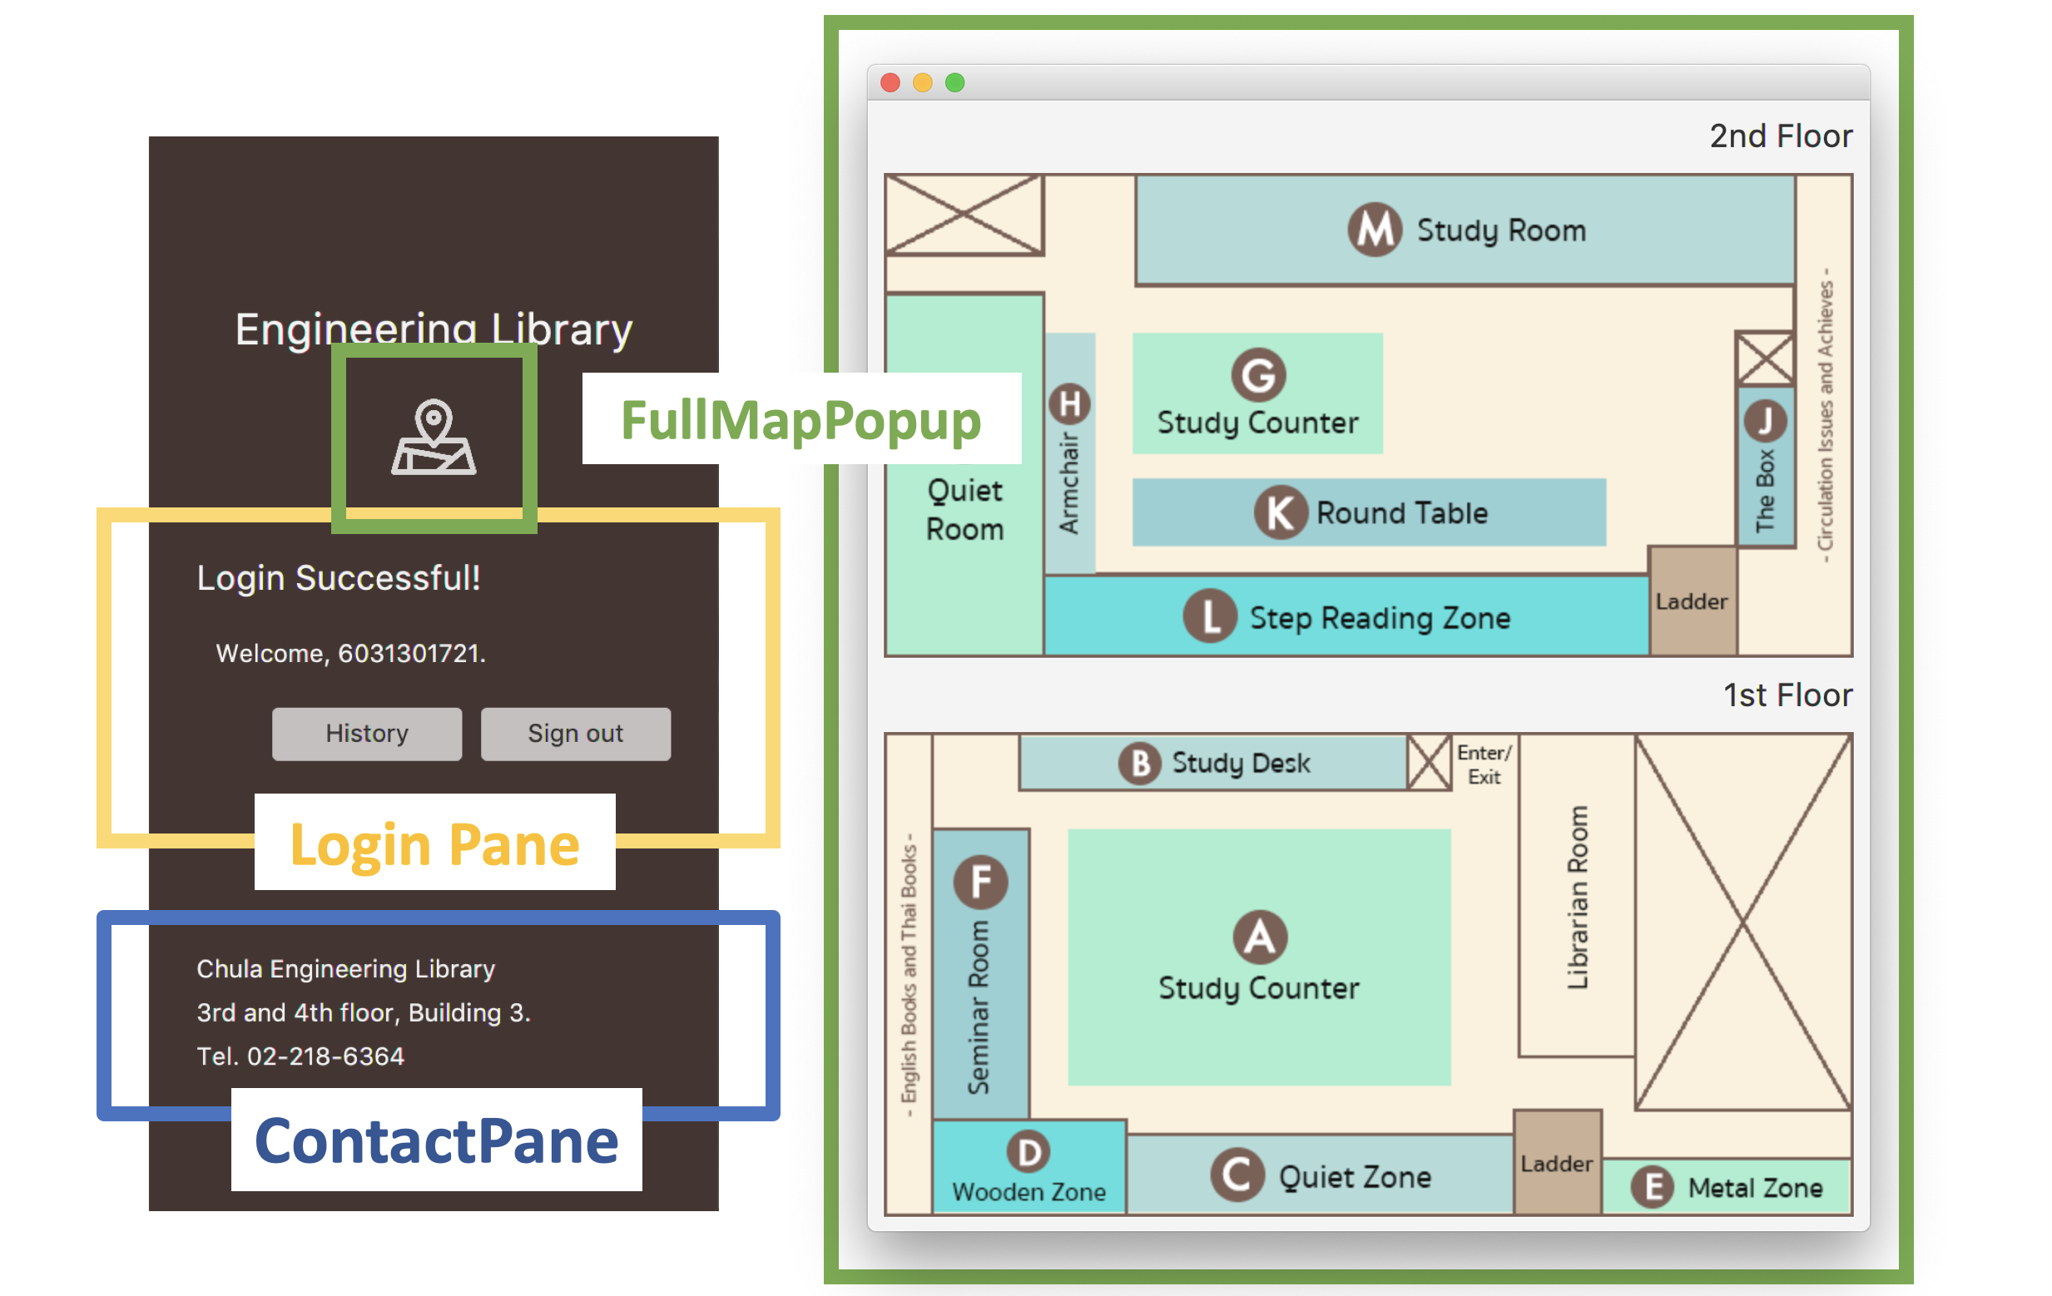

Fig 9: The outline showing components in Control Pane

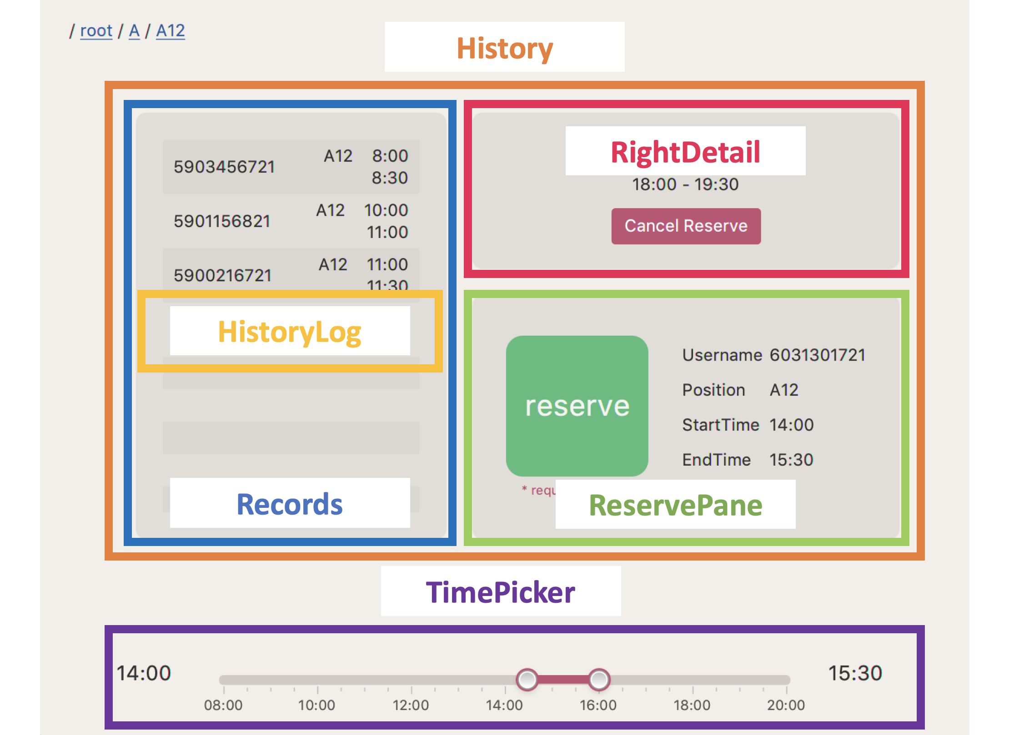

Fig 10: The outline showing components in History Pane

# Access Modifier Notations

The Access Modifier Notations in this paper can be listed below.

## Permission

|  |  |
| --- | --- |
| + | public |
| # | protected |
| - | private |

## Keywords

|  |  |
| --- | --- |
| **bold** | final |
| underlined | static |
| *italic* | abstract |

# Package application

## Interface TimeIntervalUpdate

This interface is for make other class to object depend on the time.

### Method

|  |  |
| --- | --- |
| *void intervalUpdate(long s, long t)* |  |

## Class FirstFl extends Pane implements TimeIntervalUpdate

This class is the 1st floor map, each zone on the pane is Button can navigate to each zone.

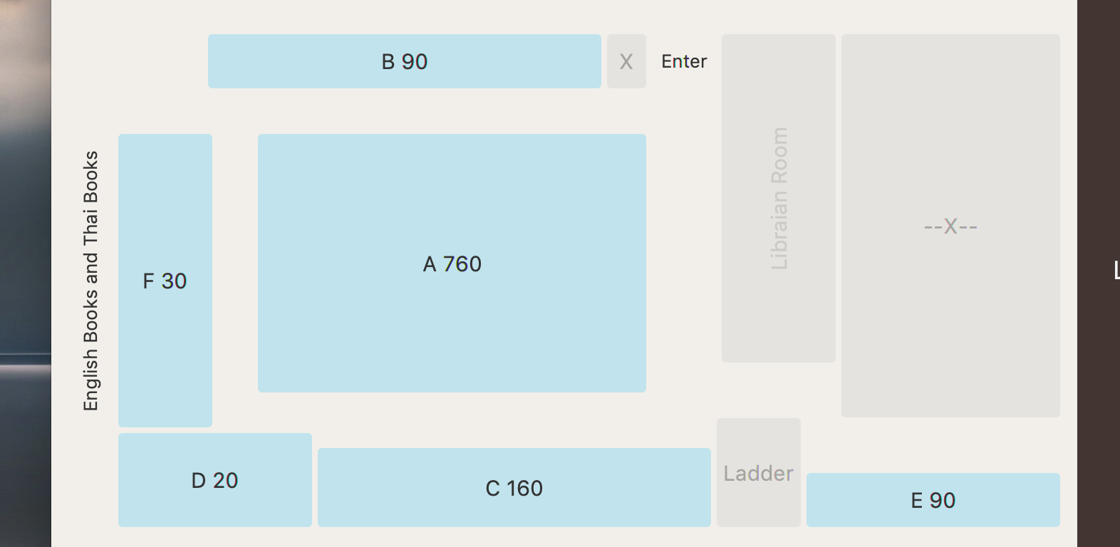

Fig : FirstFl when run application

### Field

|  |  |
| --- | --- |
| Map<String, RegionButton> btns | Map from String that is the name of zone to RegionButton that use for illustrating the zone. |

### Constructor

|  |  |
| --- | --- |
| + FirstFl() | Initializes the FirstFl. This method should:  - Sets a width of 700 and a height of 350.  - Instantiates each field:  - RegionButton of each zone, zoneA to zoneF include the non-using zone, x1, x2, ladder, and libr (Librarian room), to illustrate the map of FirstFl.  - Adds some Label to clarify each zone.  - Adds each field to the pane as a children in the correct order.  - Adds the zones to btns and adds EventHandler to each button, to make them navigate to each zone after click on.  - Sets the style of each zone. |

### Method

|  |  |
| --- | --- |
| + void intervalUpdate(long s, long t) | Refresh the available seats of each zone during input time (s is start time and t is end time) |

## Class SecondFl extends Pane implements TimeIntervalUpdate

This class is the 2nd floor map, each zone on the pane is Button can navigate to each zone.

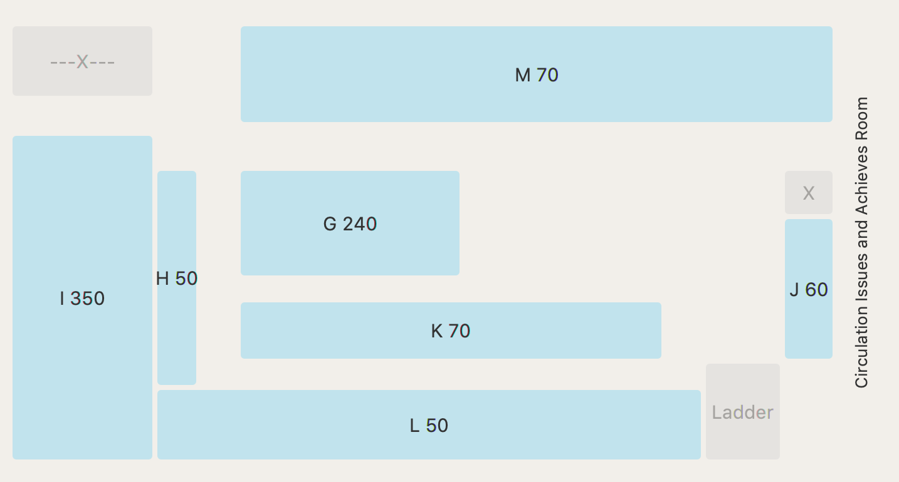

Fig : SecondFl when run application

### Field

|  |  |
| --- | --- |
| Map<String, RegionButton> btns | Map from String that is the name of zone to RegionButton that use for illustrating the zone. |

### Constructor

|  |  |
| --- | --- |
| + SecondFl() | Initializes the SecondFl. This method should:  - Sets a width of 700 and a height of 350.  - Instantiates each field:  - RegionButton of each zone, zoneG to zoneM include the non-using zone, x1, x2, and ladder to illustrate the map of SecondFl.  - Adds some Label to clarify each zone.  - Adds each field to the pane as a children in the correct order.  - Adds the zones to btns and adds EventHandler to each button, to make them navigate to each zone after click on.  - Sets the style of each zone. |

### Method

|  |  |
| --- | --- |
| + void intervalUpdate(long s, long t) | Refresh the available seats of each zone during input time (s is start time and t is end time) |

## Class RegionButton extends Button

This helper class is used for creating a specific size button at specific place on pane.

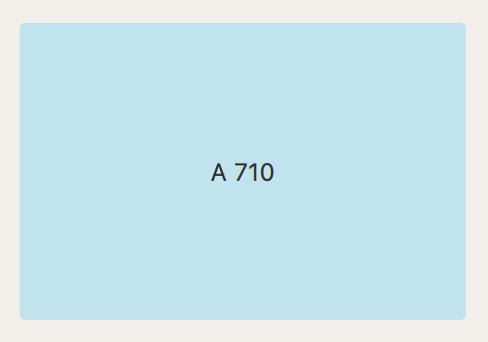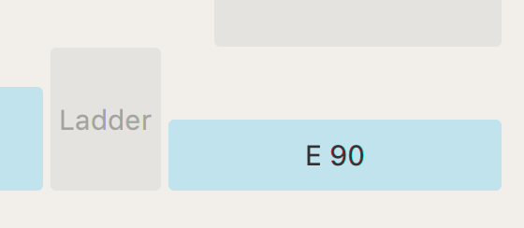

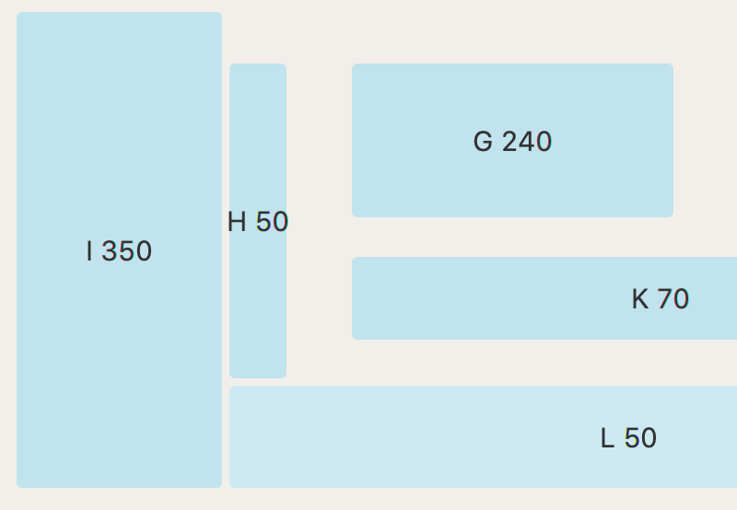

Fig : Zone button created by RegionButton

### Constructor

|  |  |
| --- | --- |
| + RegionButton(String text, double sizeX, double sizeY, double posX, double posY, boolean isDisabled) | Creates Button with a text of text, a width of sizeX, a height of sizeY, a horizontal position of posX, and a vertical position of posY. If isDisabled is true, it is set Disable. |
| + RegionButton(String text, double sizeX, double sizeY, double posX, double posY) | This constructor will call RegionButton(text, sizeX, sizeY, posX, posY, false) |

## Class QuietRoom extends VBox implements TimeIntervalUpdate

This class is used for creating a zone map that you desire.

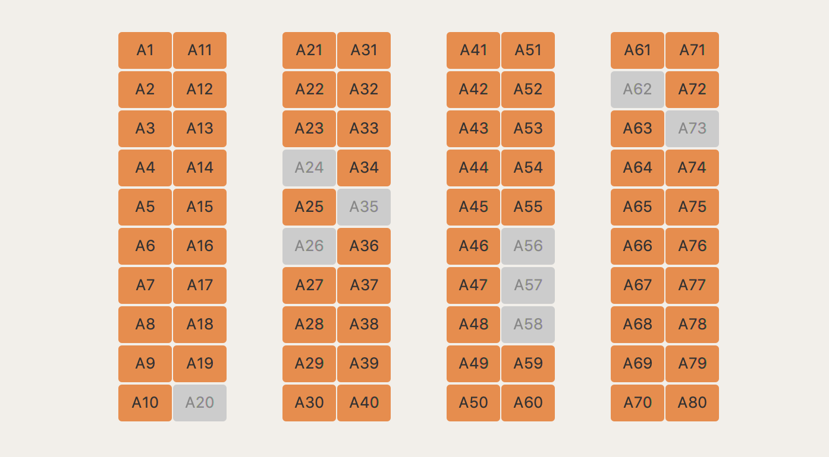

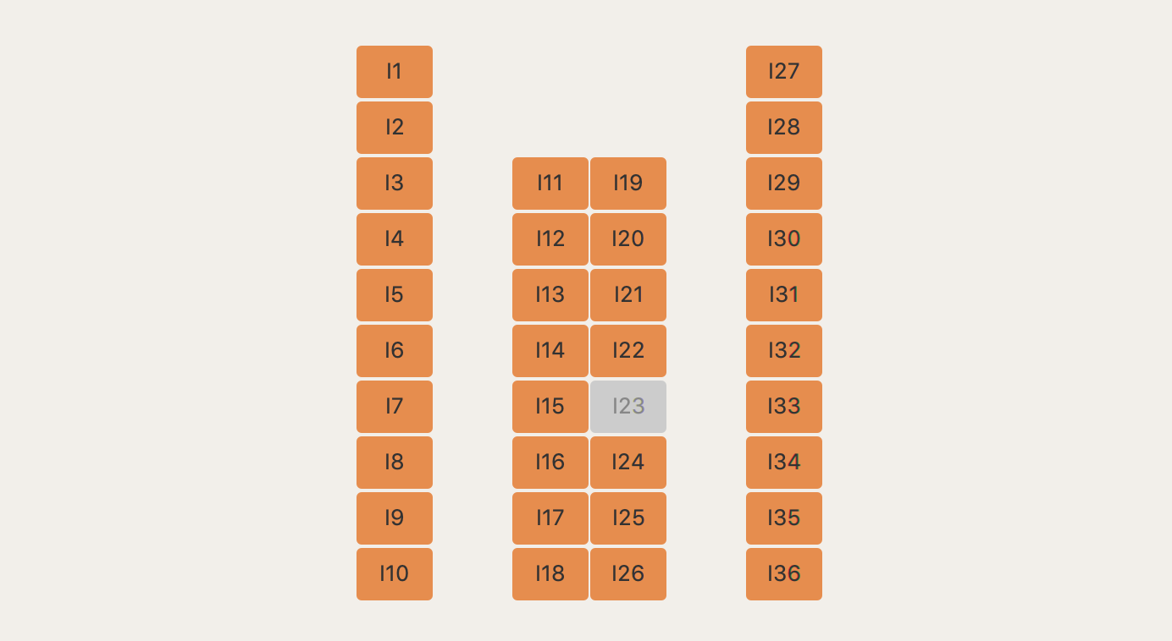

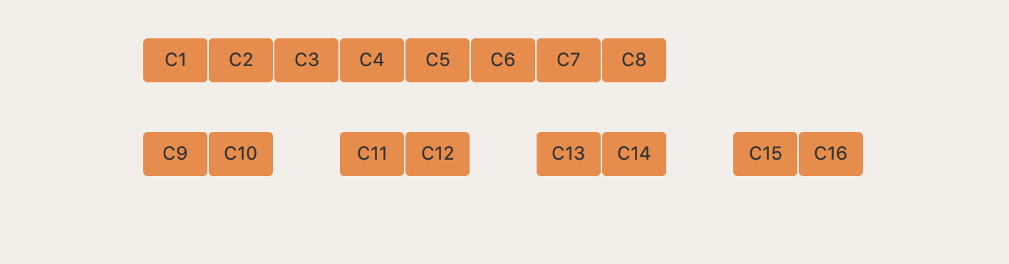

Fig : QuietRoom for illustrating zone map (top is A, middle is I, and bottom is C)

### Field

|  |  |
| --- | --- |
| - JSONObject detail | JSONObject that contains details of table in the zone. |
| - String zone | The zone that want to be generate the map. |
| - GridPane grid | The map of tables in the zone illustrate as a Buttons in GridPane. |
| - Map<String, Button> btns | Map uses for pair a name of a Button (seat name) and a Button. |

### Constructor

|  |  |
| --- | --- |
| + QuietRoom(String zone) | Initializes QuietRoom using VBox. This method should:  - Set spacing of 10  - Run updateZone(zone) |

### Method

|  |  |
| --- | --- |
| + void updateZone(String zone) | Instantiates each field:  - Sets this.zone to zone  - btns is an empty Map<String, Button>  - grid is a GridPane with horizontal gap of 1, vertical gap of 3. This is set alignment of the pane to Pos.CENTER.  - Uses try-catch statement to generate Buttons from JSONArray that illustrate Table pattern. Each Button should store in btns to make them can be navigate to the reserve panel of each seat.  - Clear all children in VBox and add grid. |
| void handle(Button btn) | If Button is clicked, the program will print “No button handle in QuietRoom.java” |
| + void intervalUpdate(long s, long t) | Refresh the available seat within time interval that input. |

## Class TimePicker extends HBox

This class is use for creating slider for selecting start time and end time of reservation. When the slider is changed, it will make other class change.

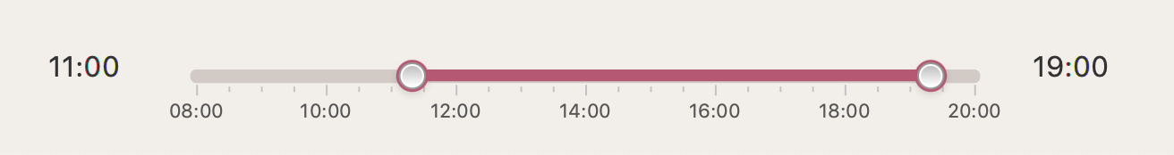

Fig : TimePicker that have been created

### Field

|  |  |
| --- | --- |
| long lowTime | Start time in term of minutes |
| long highTime | End time in term of minutes |
| Label lowLabel | Label of lowTime in time format |
| Label highLabel | Label of highTime in time format |
| RangeSlider slider | RangeSlider for selecting time interval |

### Constructor

|  |  |
| --- | --- |
| + TimePicker(boolean showLabel) | This method should:  - Run TimePicker()  - If showLabel is true, the lowLabel and highLabel is added to the HBox beside slider. |
| + TimePicker() | Initializes the TimePicker. This method should:  - Instantiate each fields:  - TimePicker using a HBox and sets alignment of the pane to Pos.CENTER.  - mn is a long int that is the Start Time in term of minutes. It should be current time but not lower than 480 (8:00) and not higher than 1200 (20:00).  - mx is a long int that is the End Time in term of minutes. It should be 60 minutes after current time but should not exceed 1200 (20:00).  - lowTime is set to roundMinute(mn)  - highTime is set to roundMinutes(mx)  - lowLabel is a Label with the text of time format of lowTime.  - highLabel is a Label with the text of time format of highTime.  - slider that is a RangeSlider should sets:  - minimum number of 480 (8:00)  - maximum number of 1200 (20:00)  - selected the value on the RangeSlider between lowTime and highTime.  - a padding inset of 15, 25, 0, and 25  - lowValue to lowTime  - highValue to highTime  - a width of 500  - a height of 50  - show Tick Labels  - show Tick Marks  - set Major Tick Unit of 120  - set Label Formatter that can convert number to time format String.  - add Listeners of lowValue and highValue to fireEvent INPUT_CHANGE for refresh all nodes that associate with time interval.  - Adds slider to the pane as a children. |

### Method

|  |  |
| --- | --- |
| String minute2str(long l) | Convert l (minutes) to time format (h:mm) |
| long roundMinute(long l) | Round l to the minutes that can be divide by 30. |
| + void setLow(long l) | Sets lowTime and lowLabel of TimePicker and lowValue of slider equal to the value of l. |
| + void setHigh(long l) | Sets highTime and highLabel of TimePicker and highValue of slider equal to the value of l. |

## Class PositionSelector extends VBox

This class is the pane can change to floor map, zone map and history pane, use for helping select the required data.

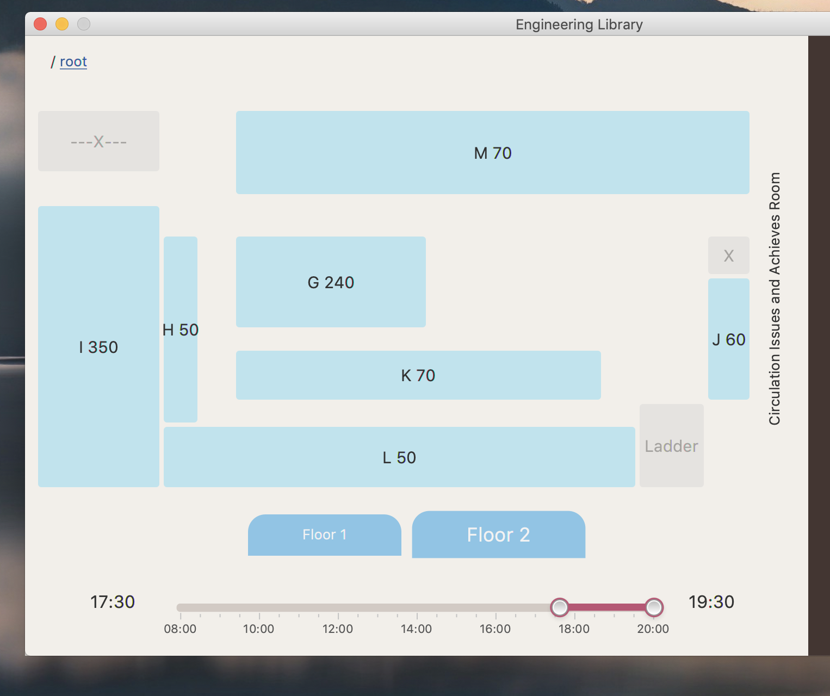

Fig : PositionSelector when “Floor 1” button selected

### Field

|  |  |
| --- | --- |
| String path | String that describe what current place are shown on the window.  This can be “/root/history” (History of reservation for each user) and “/root[/{zone}[/{seat}]]” |
| HBox navigate | HBox that contains a Label (or many Labels). Each label has a text of the zone, the seat, “root”, or “history” and can click to navigate (change the place that are shown on window) to the place that are shown on it. |
| TimePicker timePicker | An instance of TimePicker |
| HBox floorSelector | HBox that contains fl1btn and fl2btn Buttons. |
| Button fl1btn | Button that change to First Floor Map. |
| Button fl2btn | Button that change to Second Floor Map. |
| int currentFloor | The floor number 1 or 2 (Starting from floor 1) that are shown on the window. |
| VBox currentMiddleBox | VBox that show a map of floor 1 or 2, a map of zone, a reserve history of seat with the reservePane, or a reserve history of user with the reservePane. |

### Constructor

|  |  |
| --- | --- |
| + PositionSelector(String path) | This constructor is call PositionSelector() constructor and method setNavigate(path) |
| + PositionSelector() | Initializes the PositionSelector. This method should:  - Sets the alignment of the pane to Pos.TOP_CENTER, the pane has a width of 720 and a height of 570.  - Sets the inset padding of 15, 20, 15, and 20.  - Sets the vertical gap of the pane to 20.  - Sets path to “/root”.  - Instantiates each fields:  - navigate is a HBox that is set the alignment of the pane to “Pos.CENTER_LEFT” and the inset padding of 15, 20, 15, and 20.  - floorSelecter is a HBox that is set the spacing of 10, the width of 700, and the alignment of the pane to “Pos.CENTER”.  - fl1btn is a Button with a text “Floor 1”.  - fl2btn is a Button with a text “Floor 2”.  - timePicker is a TimePicker with a Label that can change the time interval while using slider. When user changes the time, the node that associated with should be refresh to this time interval.  - Adds each field to the pane as a children in the correct position.  - Adds EventHandler for the fl1btn and fl2btn Button.  - Run setNavigate(“/root”) |

### Method

|  |  |
| --- | --- |
| void setNavigate(String nav) | Changes the currentMiddleBox to the desired place that input to the method. This method should:  - Sets path as input nav and gets the smallest place (deepest path or the path after the last “/” in the sentence) into back.  - Clears all children of navigate.  - Instantiates each fields:  - level that is an int is set to 0.  - If nav has “/root” at start of the String  - a Label with a text “ / ” is added to navigate, followed by root that is a Label with a text “root”  - The label is added EventHandler that can navigate to “/root” (can run setNavigate(“/root”).  - level is set to level bitwise OR 1.  - currentMiddleBox is Floor Map (getFloor(currentFloor))  - If nav has “/root/” followed by alphabet A to Z at start of the String  - a Label with a text “ / ” is added to navigate, followed by zoneLabel that is a Label with a text from the first character of back.  - The label is added EventHandler that can navigate to “/root/” + text of zoneLabel (can run setNavigate(“/root/” + (back.substring(0,1)))  - level is set to level bitwise OR 2.  - currentMiddleBox is Zone Map (getZone(back))  - If nav has “/root/” followed by alphabet A to Z, followed by “/”, followed by alphabet A to Z and followed by number 0 to 9 at start of the String  - a Label with a text “ / ” is added to navigate, followed by seatLabel that is a Label with a text from back.  - level is set to level bitwise OR 4.  - currentMiddleBox is Reservation Panel with Reservation History of this seat (getTable(back)).  - If nav is “/root/history”  - a Label with a text “ / “ is added to navigate, followed by historyLabel that is a Label with a text “history”  - level is set to level bitwise OR 8.  - currentMiddleBox is Reservation History of the user that have login already (getHistory())  - hb is a HBox that contains currentMiddleBox. This is set the width of 800, the height of 350 and the alignment of the pane to Pos.CENTER.  - Hides floorSelector when currentMiddleBox not be navigate to any zone or any floor.  - Hides timePicker when currentMiddleBox is navigate to “/root/history”  - run timeUpdate() |
| - VBox getFloor(int i) | Returns VBox that contains Floor Map that match to the input i. This method should:  - Instantiates floor1 with FirstFl and floor2 with SecondFl  - Adds EventHandler to the zone Button to make each Button in the Floor Map can be navigate to each zone correctly.  - If i is 1 return floor1, if not return floor2. |
| - VBox getZone(String zone) | Returns VBox that contains Zone Map that match to the input zone. This method should:  - Instantiates VBox that contains QuietRoom of specific zone and Adds EventHandler  to the seat Button in QuietRoom to make each Button can be navigate to each seat correctly. |
| - VBox getTable(String seat) | Returns VBox that contains Reservation History of the input seat. This method should:  - Instantiates historyPane with History of input seat.  - Adds 2 EventHandlers to historyPane  - To refresh historyPane when there is new reserve record.  - To change the range of RangeSlider in TimePicker to the startTime and endTime of the History record that user has selected.  - Returns VBox of HistoryPane. |
| - VBox getHistory() | Returns Reservation History of user that have login already. |
| + void navigateBack() | Sets navigate upper for 1 step. In other words, sets navigate to path that remove “/” and back from the end of path. |
| - void timeUpdate() | Refreshes every node in currentMiddleBox that implements from TimeIntervalUpdate to value within time interval of timePicker. |

## Abstract Class GroupLoginInput

Some seat require many user to process reservation, this component will receive list of that user.

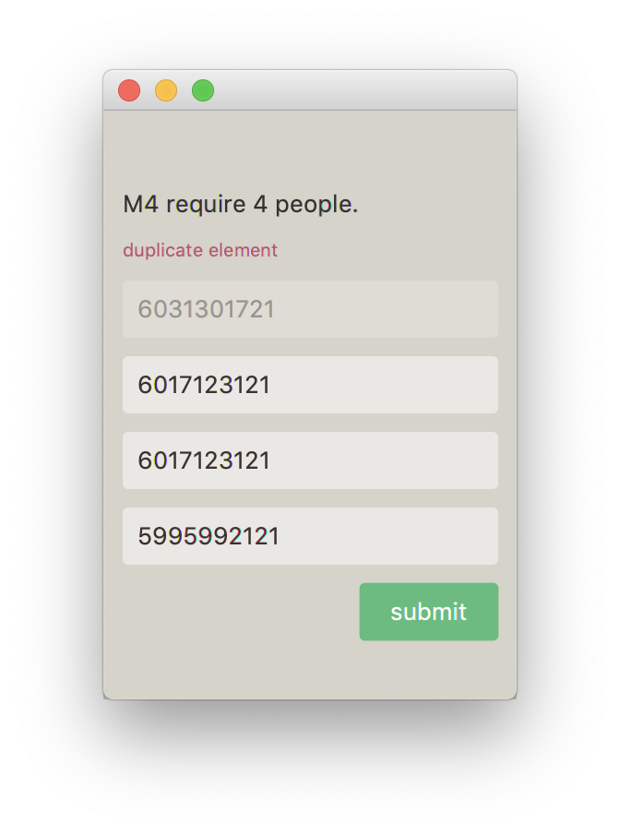

(a) (b)

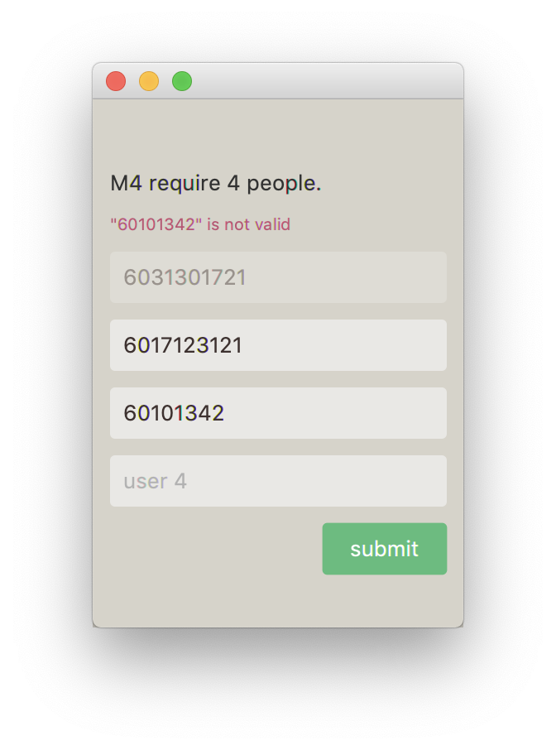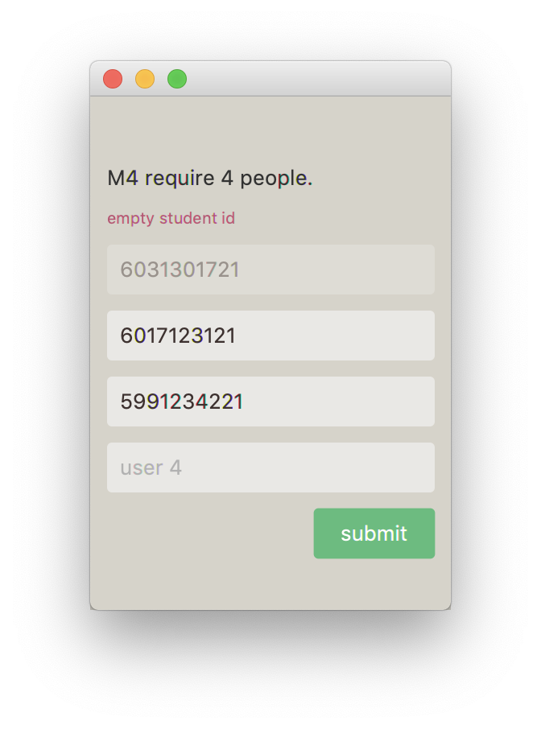

(c) (d)

Fig : GroupLoginInput for input IDs of people

(a) when created, (b) when input duplicate ID,

(c) when ID is not valid, and (d) when leave the field blank

### Field

|  |  |
| --- | --- |
| - Stage stage | Initializes Stage |
| - Label message | Initializes message using Label |
| - Button submit | Initializes Button with a text “submit” |
| - VBox middlePane | Initializes middlePane using VBox |
| - ObservableList<TextField> listInput | List of TextField of student ids |
| - int require | Number of people require for reserve seat |
| - String position | Seat position |

### Constructor

|  |  |
| --- | --- |
| + GroupLoginInput(int n, String pos) | This method should:  - Sets require to n  - Sets position to pos  - run show() |

### Method

|  |  |
| --- | --- |
| # void show() | Show the window that have textFields in listInput and “submit” Button. This method should:  - Instantiates each field:  - pane is a GridPane with a padding inset of 30, 10, 30, and 10, a vertical gap of 10. This is set alignment of the pane to Pos.CENTER.  - Clear data in listInput.  - Add textFields require times in listInput.  - Set Text at First TextField to username and Disable this TextField.  - Run setLoginPane()  - Add Label to describe the people that required in this position to pane.  - Adds each field to the pane as a children of pane in the correct position.  - Instantiates Scene with a Scene that contains pane.  - set scene to stage and show stage. |
| - void setLoginPane | This method should:  - Clear all children of middlePane  - Sets middlePane a width of 70 and a height of 100.  - If user login  - adds listInput to middlePane  - adds EventHandler to run handle() when user click on submit Button, only if isValid() is true, if not, message is set text as “Input format is not valid. Please check your student ID”  - If user not login, message is set text as “Please login” |
| + void refresh() | This method should:  - Clear message text if there are any text in message.  - if user already login and there is no textField in listInput, run setLoginPane() |
| + boolean isValid() | Return true if text in textFields in listInput is contains only numbers. |
| + void close() | Close the window |
| + ArrayList<String> getTeam() | Return username of the group that input in textFields in listInput. |
| *+ void handle()* |  |

## Class ContactPane extends VBox

This class is the contact card in ControlPane. It contains 3 Labels.

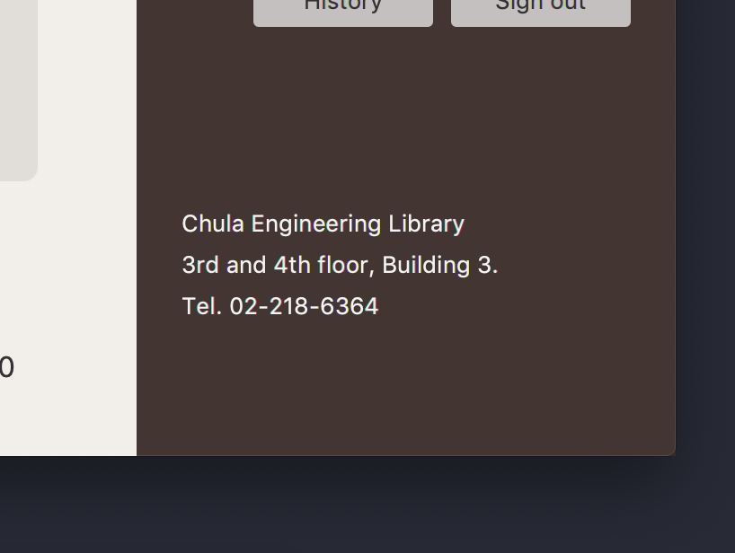

Fig 18: ContactPane in ControlPane

### Constructor

|  |  |
| --- | --- |
| + ContactPane() | Initializes the ContactPane. This method should:  - Instantiates each fields:  - location is a Label with a text “Chula Engineering Library”.  - position is a Label with a text “3rd and 4th floor, Building 3.”  - phone is a Label with a text “Tel. 02-218-6364”  - Sets the alignment of the pane to Pos.CENTER_LEFT, the pane has a width of 300.  - Sets the spacing of 6 and the inset padding of 25.  - Sets styles of the pane  - Adds each field to the pane as a children in the correct order. |

## Class FullMapPopup

Class that will pop up the map with right scale help user visualizing.



Fig : Map button on ControlPane



Fig : The window that pop up when click the button

### Field

|  |  |
| --- | --- |
| - Stage stage | Initializes Stage |

### Method

|  |  |
| --- | --- |
| + void show() | Shows the Full Map of Librarian. This method should:  - Instantiates each field:  - fullmap is a VBox with a padding inset of 10, a spacing of 10. This is set alignment of the pane to Pos.CENTER_RIGHT.  - firstFlL is a Label with a text “1st Floor”. This is set font size of 20, a bold font weight, and alignment of the pane to Pos.CENTER_RIGHT.  - secondFlL is a Label with a text “2nd Floor”. This is set font size of 20, a bold font weight, and alignment of the pane to Pos.CENTER_RIGHT.  - firstFl and secondFl is ImageView that load the image of Floor Map of each floor.  - Adds each field to the pane as a children of fullMap in the correct position.  - Instantiates mapScene with a Scene that contains fullMap. This is set a width of 620 and a height of 700.  - set mapScene to stage and show stage. |

## Class ControlPane extends VBox

This class is generating the pane contains titles of program, map button to show the library map, loginPane, and the name card. This class is the one of the two main class of program

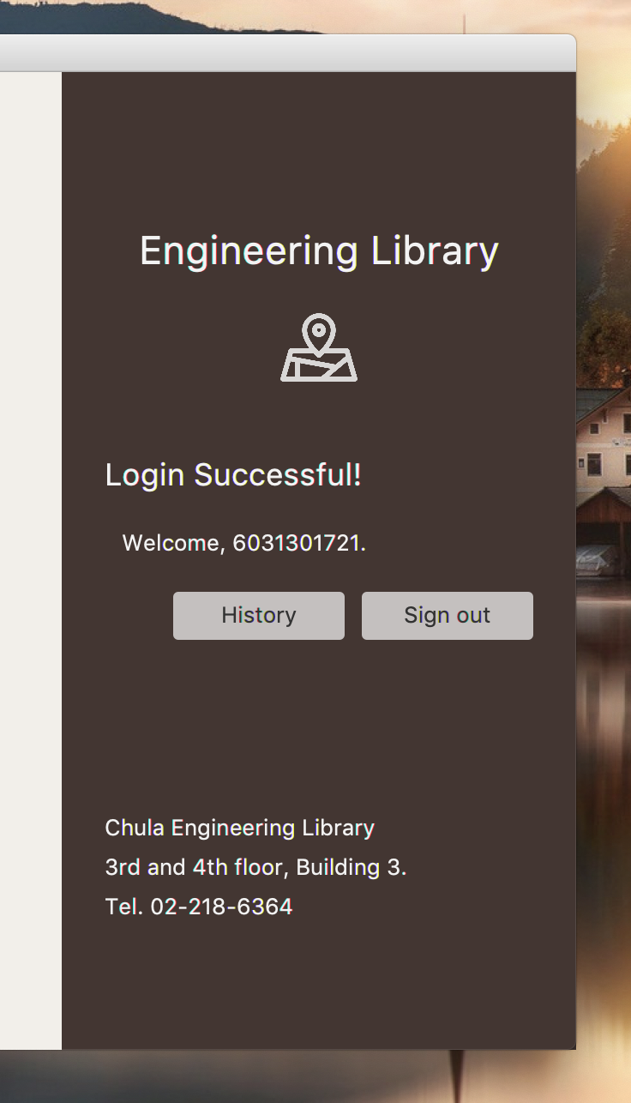

Fig : LoginPane when user have login

### Constructor

|  |  |
| --- | --- |
| + ControlPane() | Initializes the ControlPane. This method should:  - Sets the alignment of the pane to Pos.CENTER, the pane has a width of 500.  - Sets the inset padding of 90, 0, 50, and 0.  - Instantiates each field:  - title is a Label with the text “Engineering Library” that has a font size of 23 and a bold font weight  - wrapper is a HBox that contains mapBtnPane and is set alignment to Pos.CENTER  - mapBtnPane is a VBox with a mapBtn inside, this pane should set the insets padding of 15, the margin of 15, 10, 10, and 10, and sets alignment to Pos.CENTER_RIGHT.  - mapBtn is a Button with a mapLogo graphic that has a width of 45 and a height of 45. This Button should pop up the map of the library after click on.  - loginPane is a LoginPane that use for user login.  - rg is a region that is set vertical grow always.  - a ContactPane.  - Adds each field to the pane as a children in the correct order. |

## Class LoginPane extends GridPane

Component that will authenticate user before process any seat request.

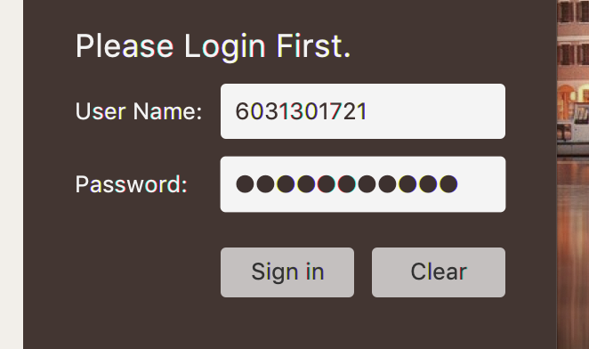

(a)

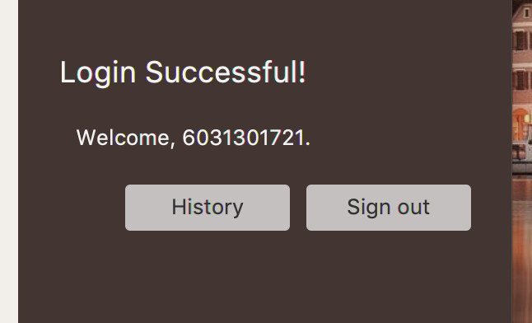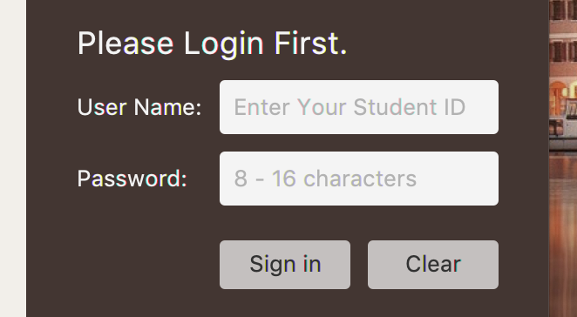

(b) (c)

Fig : LoginPane when (a) input the username and password

(b) have login (c) generated

### Field

|  |  |
| --- | --- |
| + TextField GlobalLatestUserTextField | Object to refer to userTextField. |
| - String username | User’s username (Student ID) |
| - String password | User’s password (Password of CUNET account) |
| - TextField userTextField | TextField for receiving the username |
| - PasswordField pwBox | PasswordField for receiving the password |

### Constructor

|  |  |
| --- | --- |
| + LoginPane() | Initializes the LoginPane. This method should:  - Sets the alignment of the pane to Pos.TOP_CENTER, the pane has a width of 300.  - Sets the inset padding of 25.  - Sets the horizontal gap and vertical gap of the pane to 10.  - Run the initilize(). |

### Method

|  |  |
| --- | --- |
| - void initilize() | Initializes the field that need to use while login. This method should:  - Clears the LoginPane.  Instantiates each field:  - scenetitle is a Label with the text “Please Login First.”. This is a header of the LoginPane. This is set a font size of 18 and a bold font weight.  - userName is a Label with the text “User Name:” to clarify the userTextField.  - userTextField is a TextField that is set a promptText as “Enter Your Student ID”.  - GlobalLatestUserTextField is set the value as same value as userTextField.  - pw is a Label with the text “Password:” to clarify the pwBox.  - pwBox is a PasswordField that is set a promptText as “8 - 16 characters”.  - hbBtn is a HBox that contains signinBtn and clearBtn. This is set the spacing to 10 and alignment of the pane to Pos.BOTTOM_RIGHT.  - signinBtn is a Button that run tryLogin() when user click on it. This has the text “Sign in” and a width of 75.  - clearBtn is a Button that clear the text in userTextField and pwBox. This has the text “Clear” and a width of 75.  - Adds EventHandler for each fields:  - pwBox can do trylogin() when user press ENTER key.  - signinBtn can do trylogin() when user click on.  - clearBtn can clear the text in userTextField and pwBox when user click on.  - Adds each field to the pane as a children in the correct position. |
| - boolean tryLogin() | Doing the Login process using the username and password input. This method should:  - Disable userTextField and pwBox.  - Get Text from userTextField and pwBox to store in username and password  - Run Store.login(username, password) method to check that the username and password are correct.  - if it is correct, show the Alert “Login Successful!”, run loginHandle(), and return true.  - if not, show the Alert “Wrong Username of Password!”, enable userTextField and pwBox, and return false. |
| - void loginHandle() | Initializes the field that show the profile info when login successful. This method should:  - Clears the LoginPane.  - Instantiates each field:  - success is a Label with the text “Login Successful!”. This is a header of the LoginPane. This is set a font size of 18, a bold font weight, and a width of 300.  - wellcome is a Label with the text “Welcome {username}.” that have inset padding of 10 This use for showing who is login.  - bottonPane is a HBox that contains signoutBtn and historyBtn. This is set the spacing to 10 and alignment of the pane to Pos.BOTTOM_RIGHT.  - signoutBtn is a Button that run Store.logout() and initilize() when user click on it (user can be login again). This has the text “Sign out”.  - historyBtn is a Button that show the history of reservation of this user when user click on it (user can be login again). This has the text “History”.  - Add EventHandler to bypass the LOGIN and LOGOUT event from LoginPane.  - Adds each field to the pane as a children in the correct position. |

## Class Main extends Application

Main stage for showing left and right panel.

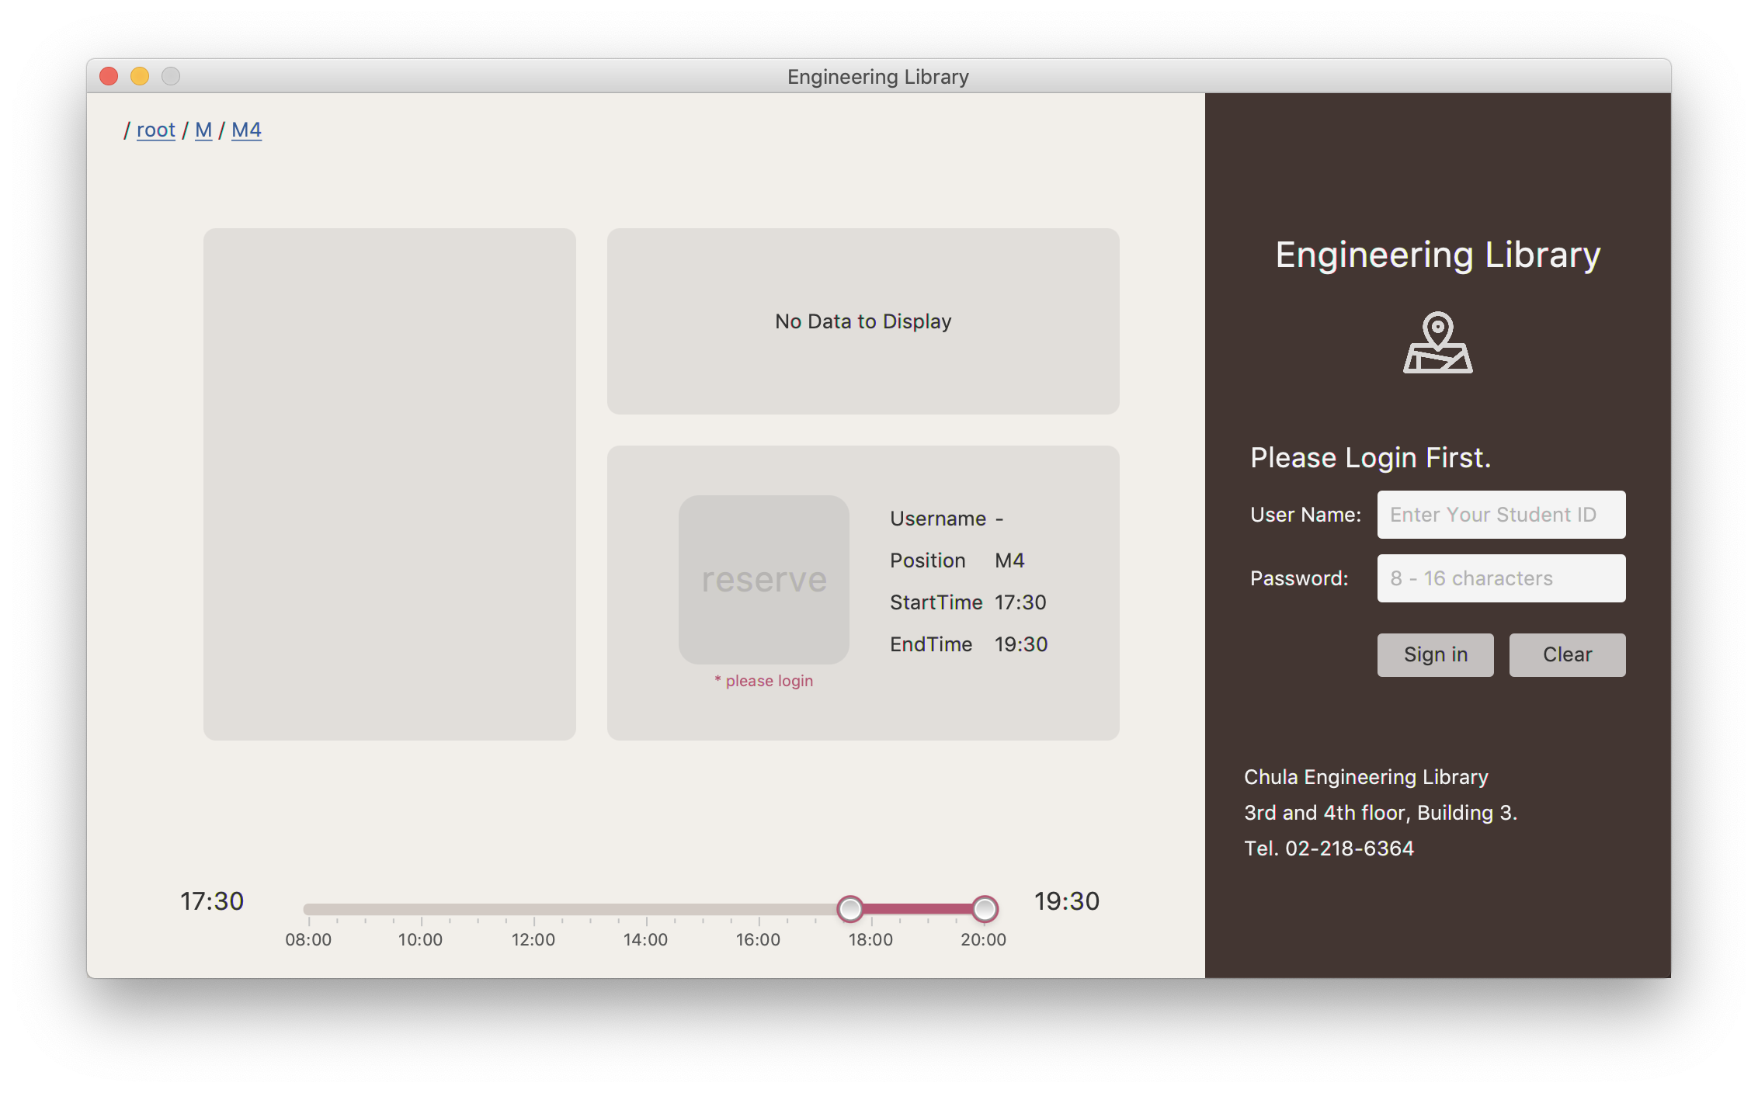

(a)

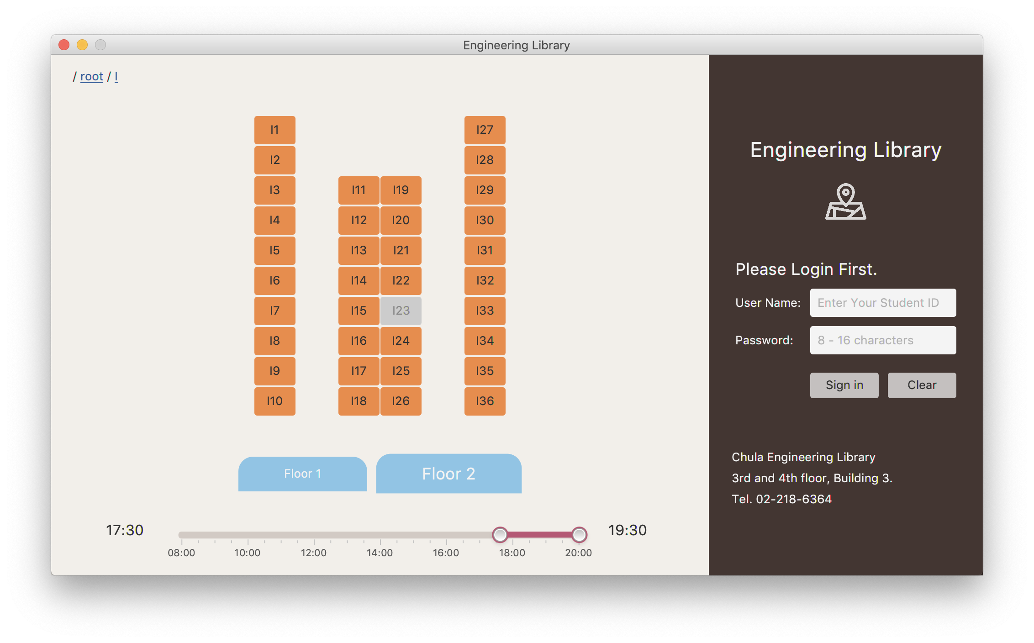

(b)

Fig : Main application

### Field

|  |  |
| --- | --- |
| PostionSelector positionSelector | An instance of PostionSelector |
| ControlPane ctrlPane | An instance of ControlPane |

### Method

|  |  |
| --- | --- |
| + void start(Stage primaryStage) | The main entry point of the JavaFX application. This method should:  - Creates a root container using GridPane.  - Initializes PostionSelector with Config.STARTER_PATH and ControlPane and add them to the root container.  - Sets the style for the scene using “style.css”  - Sets the scene with title “Engineering Library”, not resizable and then show the stage.  - Adds EventHandler to bypass the UPDATE_ROUTE Event from ControlPane to PositionSelector. |
| + void main(String[] args) | An entry point of the application. |

## CSS Style for application (style.css)

Use for add style to the components in the application package.

# Package database

## Class Axios

Helper class for write GET require easier.

### Method

|  |  |
| --- | --- |
| + AxiosResponse GET(String url) | Method for get the response from HTTP request. |

## Class AxiosResponse (Helper class of Axios)

Response of HTTP request with status code and body.

### Field

|  |  |
| --- | --- |
| - int code | HTTP status code receive from request  (eg. success = 200, bad request = 400). |
| - String data | Body of HTTP request as String. |

### Constructor

|  |  |
| --- | --- |
| AxiosResponse(int code, String data) | Constructor of AxiosResponse setting to code & data without any checking. |

### Method

|  |  |
| --- | --- |
| + int getCode() | Getter method for code field. |
| + String getData() | Getter method for data field. |
| + boolean isOK() | Check if HTTP response status code in code is accepted by or not. Accept if code = 2xx. |
| + String toString() | Return code and data as String format. |

## Class Config

Note: This class are using for helping while developing software.

### Field

|  |  |
| --- | --- |
| **+ String STARTER_PATH** | The constant value for STARTER_PATH is set to be “/root”. |
| **+ boolean AUTO_LOGIN** | The constant value for AUTO_LOGIN is set to be “false”. |
| **+ boolean ALLOW_MULTI_RESERVE** | The constant value for ALLOW_MULTI_RESERVE is set to be “false”. |
| **+ boolean FIX_DATE_TIME** | The constant value for FIX_DATE_TIME is set to be “false”. |
| **+ Date DATE_TIME** | The constant value for DATE_TIME is sets as “2018-07-06 10:00” if FIX_DATE_TIME is true. If not, this should be current date and time. |

## Class Database

Main class to connecting with server and HTTP request.

### Field

|  |  |
| --- | --- |
| - JSONObject reserve | JSONObject that contains all of reservation. |

### Method

|  |  |
| --- | --- |
| + void initialize() | Get data from JSONObject to store in reserve. |
| + ArrayList<?> toArrayList(JSONArray arr) | Return ArrayList that converted from JSONArray. |
| + ArrayList<JSONObject> sortByStartTime(ArrayList<JSONObject> arr) | Return sorted ArrayList of JSONObject by StartTime. |
| + ArrayList<JSONObject> getPositionRecordFULL(String key) | Get JSONObject that contains the full details of reservation in the seat key and return ArrayList of JSONObject, sorted by StartTime |
| + ArrayList<JSONObject> getHistory(String username) | Get JSONObject that contains the full details of reservation of username and return ArrayList of JSONObject, sorted by StartTime |
| + boolean isHistoryConflict(String username, int start, int end) | Return true, if username has reservation in the time interval input already. If not, return false. |
| + ArrayList<JSONObject> getPositionRecord(String key) | Get JSONObject that contains the details of reservation (without user details in reservation) in the seat key and return ArrayList of JSONObject, sorted by StartTime |
| + boolean add(String username, int startTime, int endTime, String position) throws NotLoginException, HistoryConflictException | Send HTTP Request to add the query of reservation, to make the reservation. Make sure that user have login and don’t have reservation at the time interval that user request. If process is success, this method will return true. |
| + boolean remove(  String username, int startTIme,  int endTime, String position) | Send HTTP Request to remove the query of reservation, to cancel the reservation. If process is success, this method will return true. |
| void refresh() | Refresh the data in Database class and Table class by using initialize() |

## Class LoginRequest

Helper class to request authentication.

### Method

|  |  |
| --- | --- |
| # boolean login(String username, String password) | Send username and password via HTTP request to external API. This will return true if username and password are correct. |

## Class Pwd

Helper class to get directory path.

### Field

|  |  |
| --- | --- |
| **+ String root** | Full path directory of current project. |
| **+ String file** | Full path directory of current project with prefix “file:” |

## Class Store

Wrapper for all authentication event.

### Field

|  |  |
| --- | --- |
| - boolean _isLogin | The login state of this application. This is set to “false” at start. |
| - String _username | The username that user login to this application. This is set to “null” at start. |

### Method

|  |  |
| --- | --- |
| + boolean login(String username, String password) | if LoginRequest(username,password) are true, set _username to username and run and return setLogin(true). If not, set _username to null and run and return setLogin(false). |
| - boolean setLogin(boolean b) | Store the login state in _isLogin as input b and return the same value. |
| + boolean isLogin() | Return _isLogin. |
| + boolean logout() | - Sets _username to null  - If isLogin() is true, run setLogin(false) and return true. If not, run setLogin(true) and return false. |
| + String getUsername() | If isLogin() is true, return _username, else, return null. |

## Class Table

Containing all static seat detail eg. require number, position on grid.

### Field

|  |  |
| --- | --- |
| - JSONObject table | JSONObject for store the seat patterns in library |
| - ArrayList<String> allseat | ArrayLst for store every seats in library |
| - ArrayList<String> allzone | ArrayLst for store every zones in library |

### Method

|  |  |
| --- | --- |
| + void initialize | Read the JSON file and convert them into JSONObject, ArrayList<String> in table, allseat, and allzone varaibles |
| + void reinitialize | Call initialize() |
| + ArrayList<String> getZones() | Return allzone |
| + JSONObject getZone(String zone) | Return the seat pattern of input zone |
| + ArrayList<ArrayList<String>> getSeats(String zone) | Return the seat pattern of input zone as 2D ArrayList |
| + ArrayList<String> getAllSeats(String zone) | Return the seat pattern of input zone as 1D ArrayList |
| + ArrayList<String> getValidSeat(long s, long t, String search) | Return the seats that available in time interval input (from s to t) as ArrayList |
| + int getRequirenumber(String pos) | Return number of user ID that required in reservation |
| + boolean isValidSeat(long s, long t, String position) | Return true if the seat is available in time interval input (from s to t) |

## JSON File (table.json)

Store table pattern of each zone in JSONObject format.

# Package event

## Class LibReserveEvent extends Event

This class is using to provide an event to communicate with direct children component that specifically relate to the program logic.

### Field

|  |  |
| --- | --- |
| **+ long serialVersionUID** |  |
| **+ EventType<LibReserveEvent> CUSTOM_EVENT_TYPE** | Declare the EventType to use for specific group of Event. |
| **+ EventType<LibReserveEvent> UPDATE_LOG** | Declare the EventType to use for specific group of Event. |
| **+ EventType<LibReserveEvent> DELETE_LOG** | Declare the EventType to use for specific group of Event. |
| **+ EventType<LibReserveEvent> FOCUS_LOG** | Declare the EventType to use for specific group of Event. |
| **+ EventType<LibReserveEvent> INPUT_CHANGE** | Declare the EventType to use for specific group of Event. |
| **+ EventType<LibReserveEvent>**  **SELECTED** | Declare the EventType to use for specific group of Event. |
| **+ EventType<LibReserveEvent> UPDATE_ROUTE** | Declare the EventType to use for specific group of Event. |
| **+ EventType<LibReserveEvent> NAVIGATE_BACK** | Declare the EventType to use for specific group of Event. |
| **+ EventType<LibReserveEvent> AUNTH_CHANGE** | Declare the EventType to use for specific group of Event. |
| **+ EventType<LibReserveEvent> LOGIN** | Declare the EventType to use for specific group of Event. |
| **+ EventType<LibReserveEvent> LOGOUT** | Declare the EventType to use for specific group of Event. |
| Object param | Parameter is used in Event (Optional) |

### Constructor

|  |  |
| --- | --- |
| + LibReserveEvent() | This method run LibReserveEvent(null) |
| + LibReserveEvent(EventType<? extends Event> typ) | This method run LibReserveEvent(typ, null) |
| + LibReserveEvent(Object param) | This method run LibReserveEvent(CUSTOM_EVENT_TYPE, null) |
| + LibReserveEvent(EventType<? Extends Event> typ, Object param) | This method run Event(typ) and sets this.param to param |

### Method

|  |  |
| --- | --- |
| + Object getParam() | Return param. |

# Package exception

## Class HistoryConflictException extends LibReserveException

### Field

|  |  |
| --- | --- |
| **- long serialVersionUID** |  |

### Constructor

|  |  |
| --- | --- |
| + HistoryConflictException() | This method run HistoryConflictException(“History Conflict is occur. One user can reserve 1 table at same time.”) |
| + HistoryConflictException(String message) | Sets message of superclass (LibReserveException) to message. |

### Method

|  |  |
| --- | --- |
| + String tinyMessage() | Return “Reserve time is conflict to previous record. Please check your history.” |

## Abstract Class LibReserveException extends Exception

### Field

|  |  |
| --- | --- |
| **- long serialVersionUID** |  |
| - String message | The error message of the Exception. |

### Constructor

|  |  |
| --- | --- |
| + LibReserveException() | This method run LibReserveException(“LibReserve Exception is occer”) |
| + LibReserveException(String message) | Sets this.message to message. |

### Method

|  |  |
| --- | --- |
| + String getMessage() | Return message. |
| + String toString() | Return getMessage(). |
| + void alert() | - Show Error Alert with a text of tinyMessage(). A title of Alert is “Error” and the Header Text is “Cannot Reserve”.  - When close the Alert, the cursor will focus on userTextField for helping user login. |
| *+ String tinyMessage()* | Return message in tiny version if possible. |

## Class NotLoginException extends LibReserveException

### Field

|  |  |
| --- | --- |
| **- long serialVersionUID** |  |

### Constructor

|  |  |
| --- | --- |
| + NotLoginException() | This method run NotLoginException(“NotLoginException is occur. Please login to process.”) |
| + NotLoginException(String message) | Sets message of superclass (LibReserveException) to message. |

### Method

|  |  |
| --- | --- |
| + String tinyMessage() | Return “You are not login.” |

# Package history

## Class History extends GridPane implements TimeIntervalUpdate

Controller of reserve and unreserve at specific position and time.

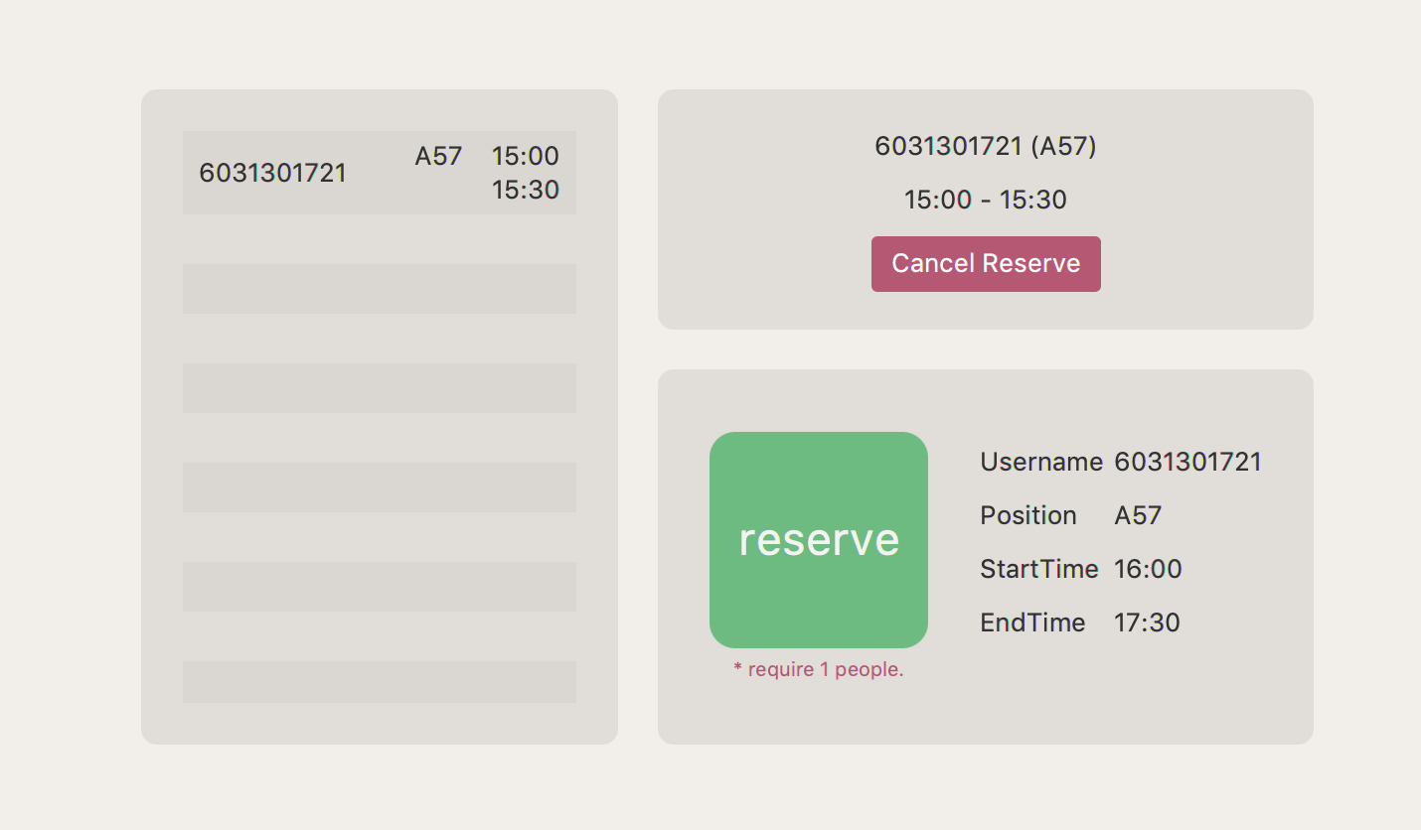

Fig : HistoryPane with 1 record.

### Field

|  |  |
| --- | --- |
| + History latestHistory | Object for refer to the latestHistory Object |
| String position | Seat position (Start with 1 alphabet and end with number) |
| String username | Username of user that login |
| boolean userlog | To clarify that the method should return History of user or History on position. It true it could be History of user. |
| # Log currentLog | The Log of specific user or position that requested. |
| # Records recordsPane | The pane that contains many of Log. |
| # RightDetails rightDetail | The pane that contains details of current reservation and cancel reservation. |
| # ReservePane reservePane | The pane that contains details of doing reservation. |

### Constructor

|  |  |
| --- | --- |
| + History(String str) | This method run History(str, false) |
| + History(String str, boolean userlog) | Initializes the History. This method should:  - If userlog is true, username is set to str and position is set to “-”  - If not, username is set to “-” and position is set to str.  - Set the horizontal and vertical gap of 20.  - Sets this.userlog to userlog  - Instantiates each field:  - If userlog is true, recordsPane is a Records of Database.getHistory(username). If not, recordsPane is a Records of Database.getPositionRecordFULL(position)  - rightDetail using RightDetail  - reservePane using ReservePane, and setSeat of the reservePane to position  - Add EventHandler to each field:  - fireEvent from rightDetail to recordsPane when delete log to make recordsPane run remove method.  - fireEvent from recordsPane to rightDetail when focus on recordsPane to make rightDetail run focus method  - when the reservePane update log, make this pane run initialize()  - Adds each field to the pane as a children of this pane in the correct position.  - Run initialize()  - Sets latestHistory refer to this.  - Add EventHandler to make this run initialize again when login and logout. |

### Method

|  |  |
| --- | --- |
| + void initialize() | The method run reservePane.initialize() and recordsPane.initialze() |
| + void intervalUpdate(long s, long t) | Refresh the History during input time (s is start time and t is end time) |

## Class HistoryLog extends Hbox

Wrapper for reserving detail.

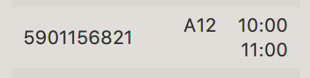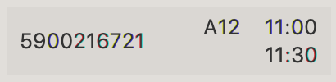

Fig : Example of Historylog

### Field

|  |  |
| --- | --- |
| Log log | log of the reserve store in Log. |

### Constructor

|  |  |
| --- | --- |
| + HistoryLog(**Log log**) | Initializes the HistoryLog using Hbox. This method should:  - Instantiates this pane and sets alignment of the pane to Pos.CENTER.  - Sets this.log to log.  - Instantiates each field:  - nm is a final Label with a text of username.  - tm1 is a final Label with a text of position and startTime.  - tm2 is a final Label with a text of endTime.  - vb is a Vbox that contains tm1 and tm2 and is set alignment of the pane to Pos.CENTER_RIGHT.  - rg is a final Region that is set horizontal grow as Priority.ALWAYS.  - Adds each field to the pane as a children of this pane in the correct order. |

### Method

|  |  |
| --- | --- |
| Log getLog() | Return log (Getter for Log Field). |

## Class Log

Wrapper for seat recorded data.

### Field

|  |  |
| --- | --- |
| **+ SimpleDateFormat TIMEFORMAT** | Constant variable for using. This value is new SimpleDateFormat(“HH:mm”) |
| **+ SimpleDateFormat DATEFORMAT** | Constant variable for using. This value is new SimpleDateFormat(“yyyy-MM-dd”) |
| **+ SimpleDateFormat DATETIMEFORMAT** | Constant variable for using. This value is new SimpleDateFormat(“yyyy-MM-dd HH:mm”) |
| + String username | Username of user that login |
| + String position | Seat position (Start with 1 alphabet and end with number) |
| + Integer startTime | Start time of the reservation that user want. |
| + Integer endTime | End time of the reservation that user want. |
| + Integer reserveTime | The time that user request the reservation. |

### Constructor

|  |  |
| --- | --- |
| + Log(String username, int startTime, int endTime, String position) | Instantiates each field:  - this.username is set to username  - this.startTime is set to startTime  - this.endTime is set to endTime  - this.position is set to position  - this.reserveTime is set to 0. |
| + Log(JSONObject jo) | Instantiates each field by extact from JSONObject. |

### Method

|  |  |
| --- | --- |
| + String getNowTime() | Return current time in TIMEFORMAT format. |
| + String getNowDate() | Return current date in DATEFORMAT format. |
| + String getNowDateTime() | Return current date and time in DATETIMEFORMAT format. |
| + long getNowTimeMinute() | Return current time in minutes (60 * HH + mm) |
| String toSimpleTime(int tm) | Return time that input as int in TIMEFORMAT format. |
| + String getUser() | Return username. |
| + String getZone() | Return zone of the seat position. |
| + String getSeat() | Return number of seat in the zone. |
| + String getStartTime() | Return startTime in TIMEFORMAT format. |
| + String getEndTime() | Return endTime in TIMEFORMAT format. |
| + String getReserveTime() | Return reserveTime in TIMEFORMAT format. |
| + String getPosition() | Return position (getZone() + getSeat()) |
| + String getTitle() | Return getZone() + getSeat() + “ ” + getStartTime() |
| + String toString() | Return “LOG: ” + getUser() + “ ” + getPosition() + “ ” + getStartTime() + “ ” + getEndTime() |
| + boolean equals(Log log) | This method return true if this.log and log can be print (use method toString()) as the same String. |

## Class Records extends Vbox

Rendering records which allow to select item.

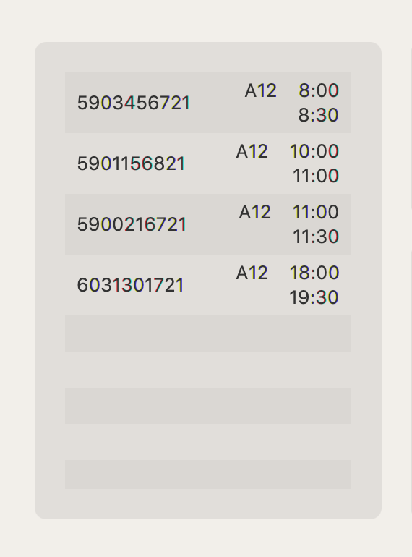

Fig : Records Pane that have 4 logs

### Field

|  |  |
| --- | --- |
| **# ObservableList<HistoryLog> labelList** |  |
| - Supplier<ArrayList<JSONObject>> getRecords |  |
| - ListView<HistoryLog> listView |  |
| - Log currentLog |  |

### Constructor

|  |  |
| --- | --- |
| + Records (Supplier<ArrayList<JSONObject>> getRecords) | Initializes the Records using Vbox. This method should:  - Instantiates this pane and sets alignment of the pane to Pos.CENTER.  - Instantiates each field:  - listView is a ListView<HistoryLog> of labelList.  - Sets this.getRecords to getRecords.  - Adds ListView to the pane as a children of this pane.  - Run initialize() |

### Method

|  |  |
| --- | --- |
| + void initialize() |  |
| + void remove(Log param) | remove Log on labelList that equals to input param. |
| + Log getCurrentLog() | Return currentLog |
| + Log setCurrentLog(Log currentLog) | This method should:  - Sets this.currentLog to currentLog if this.currentLog is not equal to currentLog  - Run nitialize().  - Run focus(currentLog)  - return currentLog |
| + void focus(Log log) | Focus on Log on labelList that equals to input log. |

## Class ReservePane extends Hbox implements TimeIntervalUpdate

Reserving button review reserve detail before process.

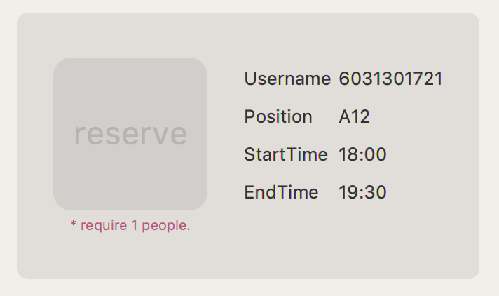

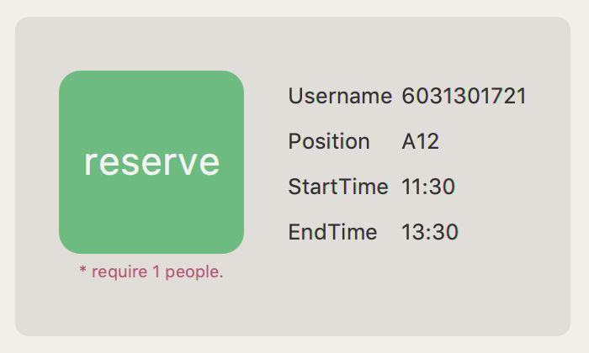

Fig : ReservePane when can reserve and cannot reserve

### Field

|  |  |
| --- | --- |
| Button submitBtn |  |
| int s | Memoi startTime |
| int t | Memoi endTime |
| String seat | Memoi Seat position |

### Constructor

|  |  |
| --- | --- |
| ReservePane() | Redirect to ReservePane(“-”, 0, 0) |
| ResrevePane(String seat, int s, int t) | Copy arguments to class field, set style and call initialize() |

### Method

|  |  |
| --- | --- |
| - Log getLog() | Return Log from class field data and Store.getUsername() but set username to “-“ if not login yet |
| + void initialize() | Clear child.  Set helper text  if not login: “* please login”  else if seat == “-”: “* history mode”  else: “* require {Table.getRequirenumber (seat)} people”  create submitBtn = “reserve”  handle click by  if not Database.isHistoryConflict(*log) then  popup GroupLoginInput (save to currentGroupLoginInput) implement unimplement method  @onsucess  If Database.add(*log) success then fireEvent(UPDATE_LOG) and this.close() for close pop up  Else set submitBtn to disable  @onclose  set submitBtn to disable  set submitBtn to enable if  isLogin() & Table.isValidSeat & log.startTime != log.endTime  else set submitBtn to disable  set style and display all component |
| + void intervalUpdate(long s, long t) | Update s and t then initialize() |
| + GridPane getTable() | Return GridPane display info from getLog() |
| + void setSeat(String position) | Set seat field = position |

## Class RightDetail extends Vbox

Button that will cancel previous reserve.

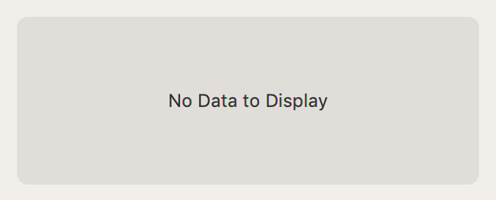

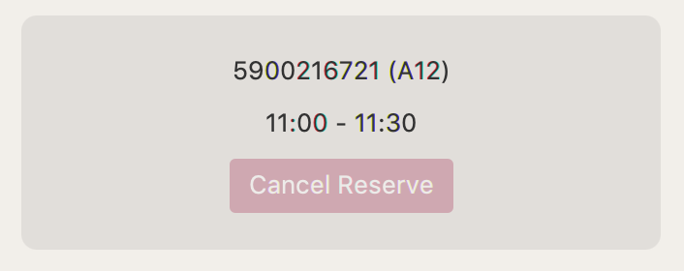

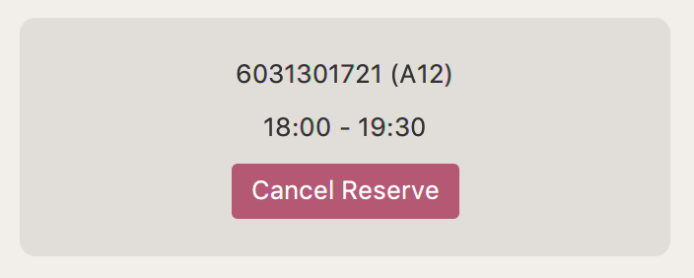

Fig : RightDetail pane when nothing selected,   
cannot cancel reserve and can cancel reserve

### Field

|  |  |
| --- | --- |
| - Button cancelReserve | Holding Cancel Reserve Button |
| - Log log | Field data for display |

### Constructor

|  |  |
| --- | --- |
| RightDetail() | Set style and calling set() |
| RightDetail(Log log) | Set style and calling set(log) |

### Method

|  |  |
| --- | --- |
| + void set() | Clear all field & children cimponent.  Disply Label(“No Data to Display”) |
| + void set(Log log) | Showing data from log.  Create Button(“CancelReserve”) and save to cancelReserve  if allowcancel() then cancelReserve have been press you must remove log from Database (Database.remove(*log))  , fireEvent(DELETE_LOG, log) and  clear screen by set()  else set cancelReserve to Disable |
| - boolean allowcancel() | Return true is Store.isLogin() and log.getUser() equal to Store.getUsername() |
| + void focus(Log param) | Call set(param) |

# Package utility

## Class STD

Helper class for easier implementation.

### Method

|  |  |
| --- | --- |
| + <T> T back(T[] ar) | Return the last data of input Array. |
| + int count(String str, String tok) | Count specific word (tok) in the sentence (str). |